**CHEMISTRY SS1**

**SCHEME OF WORK FOR ALPHA TERM**

**WEEKS TOPICS**

1. INTRODUCTION TO CHEMISTRY
2. NATURE OF MATTER
3. ELEMENTS
4. MOLECULES AND ATOMICITY
5. PARTICULATE NATURE OF MATTER
6. THE RELATIVE ATOMIC MASSES OF ELEMENTS
7. COMPOUNDS
8. IUPAC NOMENCLATURE OF CHEMICAL COMPOUNDS
9. MIXTURES
10. PRACTICALS ON SEPERATION OF MIXTURES

WEEK 1

**Chemistry as a Subject and as a Central Science**

Chemistry as a Subject and as a Central Science

**CHEMISTRY AS A DISCIPLINE**

Human mind has always been very curious to make investigations and know about various activities/phenomena occurring around him. This curiosity has led him to collect information through experiments and observations. The curious mind has also been responsible for the research activities of various people all over the world. The knowledge and data base acquired like this is then systematized in a way that the mankind takes maximum benefit out of it. This knowledge base is known as science. Science may, thus, be broadly defined as systematized knowledge gained by mankind through observations and experimentation. Science has been further classified into different branches due to its enormous expansion and diversified fields. Some examples are: Chemistry, Physics, Biology, Geology, etc. Chemistry is one of the most important discipline of science to which this present book is devoted.

**CHEMISTRY AS A SUBJECT AND AS A CENTRAL SCIENCE**

Chemistry may be defined as the branch of science which deals with the study of matter, its composition, its properties and the changes which it undergoes in composition as well as in energy during various processes.

The word chemistry has been derived from the word alchemy, which means ‘study of met also Alchemy itself might have come from al chemical marked effect on our present day life. Chemistry has helped us to meet all our requirement for better living. The continuous

research  in the field of chemistry has resulted in the production of useful materials such as, clothes, drugs, artificial foods, plastics, rubbers, fertilizers, insecticides, weed killers, life

supporting products, etc., which have revolutionised our life.

Our life would have been very dull and dreary without the knowledge of chemistry. In fact, we can say, chemistry is everywhere in the world around us; it is, in what we eat; in what we breathe; in how we live and even in what we are.

**CHEMISTRY-A CENTRAL SCIENCE**

Modem chemistry is an abstract subject whose study presents a great intellectual challenges and rewards. It is a practical field at the hub of man’s future.

Modern chemistry is CENTRAL DISCIPLINE, which correlates almost all branches of science. It is used to study biological, physical, medical as well as environmental phenomena. For example, a chemist works with:

• biologist to understand life processes and metabolic activities,

• physicist to understand properties of matter and to develope new sources of energy,

• geologist to probe outer and inner space,

• physician to design new drugs and medicines,

• ecologist to make improvement in environment,

• engineers and technical manager to provide material and energy for better life.

Chemistry, thus responds to all social needs. It plays critical role in any attempt to: discover new processes; tap new energy sources; develop new materials feed the people properly; improve health and conquer disease, monitor and protect our environment.

**BRANCHES OF CHEMISTRY**

Chemistry can be broadly divided into Pure Chemistry and Applied Chemistry.

**A. PURE CHEMISTRY**

Pure chemistry deals with the attempt to get better  understanding of nature.

Pure chemistry is further divided into three main branches. Organic chemistry, Inorganic  Chemistry and Physical chemistry. These main branches have been further divided into large number of sub-sections. The main branches meaning divided into large number of sub-sections. The main branches are described briefly as follows:

1. Organic Chemistry. This branch of chemistry deals with the study of structure, chemical composition and characteristics of compounds of carbon and hydrogen elements (Hydrocarbons) and their derivatives.
2. Inorganic Chemistry. This branch concerns itself to the study of structure, composition and behaviour of the inorganic compounds, i.e., the compounds other than hydrocarbons or their derivatives. Such compounds are found in the crust of the earth and constitute non-living matter.
3. Physical Chemistry. This branch deals with the study of fundamental principles governing various chemical transformations and chemical systems. It is primarily concerned with laws and theories of different branches of chemistry.

**B. APPLIED CHEMISTRY**

Applied chemistry deals with the application of the knowledge of chemistry for the benefit of mankind. The different branches of applied chemistry are as under:

**1.     Analytical Chemistry**. This branch involves collection of techniques which allows exact determination of the composition of the given sample of material. It has been further divided into two categories:

(a) Qualitative analysis. It deals with the identification of various constituent particles (atoms, ions, molecules) present in the material.

(b) Quantitative analysis. It deals with the estimation of various constituents in the material.

**2.     Industrial Chemistry**. This branch deals with the chemistry involved in different industrial processes such as manufacture of various chemical substances.

**3.     Biochemistry.** This branch concerns itself to the study of metabolic pathways and enzymology pertaining to living organism. It deals with molecular, cellular and chemical activities of living organisms.

**4.     Geochemistry**. This branch deals with the chemical processes occurring on earth such as metamorphism of rocks, formation of petroleum, etc. It also deals with the composition of soils and rocks.

**5.     Petrochemistry**. It is the branch of chemistry which deals with the transformation of crude oil (petroleum) and natural gas into useful products and raw materials.

**6.     Radiochemistry.** It is a branch of chemistry which deals with the study of radioactive materials, both natural as well as man-made. It also involves the use of radioactive materials to study the pathways/mechanism of ordinary chemical reactions.

**7.     Biotechnology**. It refers to the technological applications which uses biological systems, living organisms or their cterivatives to make or modify products or process for specific use. Biotechnology, infact, combines various disciplines like genetics, molecular biology, biochemistry, embryology and cell biology for developing techniques for beneficial effects.

**8.     Medicinal or Pharmaceutical Chemistry**. It is scientific discipline at the intersection of chemistry and pharmacology, which is involved with designing  synthesizing and developing pharmaceutical drugs. Medicinal chemistry involves the identification, synthesis and development of new chemical entities suitable for therapeutic use. Medicinal chemistry is highly interdisciplinary science that combines organic chemistry with biochemistry, pharmacology, *pharmacognosy; molecular biology, statistics and physical chemistry.

**Environmental Chemistry.** It is a branch of chemistry which deals with scientific study of chemical and biochemical phenomena that occur in natural places. Environmental chemistry is also an interdisciplinary science that includes atmospheric, aquatic, and soil chemistry along with analytical chemistry, environmental studies and other areas of science.

**CAREER OPPORTUNITIES**

Since chemistry is a central science because of its multidisciplinary nature, therefore, chemistry students can persue their careers in the field of industries, education, research work, government agencies and other non raditional fields. Some of the careers  opportunities, that a student with degree in chemistry can have are as follows:

**1.     Industries.** Chemical industries employ about 66% of all the chemists. The majority of them find opportunity in research and product development (Rand D), sales, or marketing. Many of them work in quality control analysis and testing products. Other find work in areas like industrial hygiene and safety or regulatory work for environmental compliance.

*pharmacognosy is a study of medicines derived from natural

**2.** Academic Institutions. Educational institutions employ about 26% of the chemists. Ph. D. degrees are required for most of academic positions at the colleges and universities. Some of chemists having graduation degree in education take up teaching assignments in high schools.

**3.** Government Agencies. Government-employ about 7Cfr: of all the chemists. Federal, local and state Government agencies hire chemists for variety of jobs including basic research, testing work required to enforce government regulations, technical program managers, authors/ editors of technical documents and government regulations.

**4.** Non-traditional Fields. A small percentage of chemists (about 1%) find work in non -traditional fields. They get opportunities to become patent lawyers, science writers, information specialists, technical librarians, technical consultants or business owners.

**Group Discussion**

Identify two applied chemistry professions and explain the chemistry they practice.

**Hints:** For reference, the two important professions associated with applied chemistry are being discussed as follows:

1. **Analyst:** Analysts find jobs in chemical industry,  food industry and pathological laboratories. In chemical industries, they control the quality of final product through chemical analysis of the product. In food laboratories, they analyse the food items to detect adultration. In pathological labs they carry out chemical tests on sample of blood or urine to help the doctor for diagnosis of disease.
2. **Research scientist**. Research scientists find jobs in pharmaceutical companies where they can use their knowledge of chemistry in developing more convenient and economical methods for the synthesis of drugs. They can also help in designing new drugs.

Different career options in chemistry are summarized in Fig. 11

[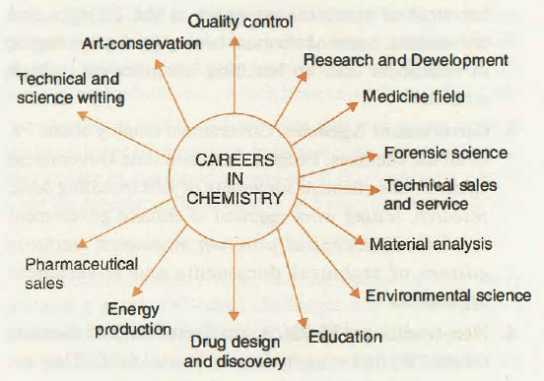](http://www.chemistry-assignment.com/wp-content/uploads/2012/12/a1.png)

**Various careers associated with chemistry.**

Chemistry is the study of matter, its composition, its properties and changes which it undergoes in composition as well as energy during various transformations. Chemistry is a central science discipline which correlates various important branches of science. Chemistry can be divided into pure and applied chemistry. Pure Chemistry has three main branches viz organic, inorganic and physical chemistry while chemistry applied has branches namely biochemistry, analytical

chemistry, radiochemistry, geochemistry, petro chemistry, environmental chemistry and biotechnology.

**EVALUATION**

l. Which branch of pure chemistry deals with the study of compounds associated with non-living sources?

(a) Physical chemistry             (b) Organic chemistry

(c) Biochemistry                      (d) Inorganic chemistry

2. Which of the following is not a applied chemistry?

(a) Geochemistry         (b) Biochemistry

(c) Radiochemistry      (d) inorganic chemistry.

3. In order to design new drug, a chemist has to seek the help of

(a) Engineer                 (b) Geologist

(c) Zoologist               (d) Physician.

4. The branch of chemistry which deals with the study of hydrocarbons is called

(a) Organic chemistry              (c) Radiochemistry

(b) Inorganic chemistry           (d) Nuclear chemistry.

**II. Fill in the Blanks**

5. Complete the following sentences by supplying appropriate words:

(i) Ecologist and chemist work together to ….. .

(ii) The branch of pure chemistry which deals with study of fundamental laws and principles is called  …..

(iii) Qualitative analysis deals with  ….. .

(iv) Radiochemistry deals with the study of  …..  substances.

(v) The phenomenon of metamorphosis of rocks is studied by ….. branch of chemistry. m.

**Discussion Questions**

6. Define chemistry and its various disciplines.

7. Comment on the statement that chemistry is a central science discipline.

8. Write the names of various disciplines of applied chemistry. Define any two of them.

9. Name and define various branches of pure chemistry.

10. Give a brief account of various career options of degree holder in chemistry.

## **THE SCIENTIFIC METHOD**

When conducting research, scientists use the scientific method to collect measurable, [empiricalevidence](http://www.livescience.com/21456-empirical-evidence-a-definition.html) in an experiment related to a [hypothesis](http://www.livescience.com/21490-what-is-a-scientific-hypothesis-definition-of-hypothesis.html) (often in the form of an if/then statement), the results aiming to support or contradict a [theory](http://www.livescience.com/21491-what-is-a-scientific-theory-definition-of-theory.html).

The steps of the scientific method s are:

1. Make an observation or observations.
2. Ask questions about the observations and gather information.
3. Form a hypothesis — a tentative description of what’s been observed, and make predictions based on that hypothesis.
4. Test the hypothesis and predictions in an experiment that can be reproduced.
5. Analyze the data and draw conclusions; accept or reject the hypothesis or modify the hypothesis if necessary.
6. Reproduce the experiment until there are no discrepancies between observations and theory.

# CHEMISTRY LABORATORY COMMON EQUIPMENT

|  |
| --- |
| Below are photos and names of common lab equipment you will encounter in Chemistry. |

|  |  |  |  |
| --- | --- | --- | --- |
| http://www.smc.edu/AcademicPrograms/PhysicalSciences/PublishingImages/P_ebalance.jpg Balance (electronic) | http://www.smc.edu/AcademicPrograms/PhysicalSciences/PublishingImages/P_beakers.jpg Beakers | http://www.smc.edu/AcademicPrograms/PhysicalSciences/PublishingImages/P_bunsen.jpg Bunsen Burner | http://www.smc.edu/AcademicPrograms/PhysicalSciences/PublishingImages/P_buret.jpg Buret |
| http://www.smc.edu/AcademicPrograms/PhysicalSciences/PublishingImages/P_claytriangle.jpg Clay Triangle | http://www.smc.edu/AcademicPrograms/PhysicalSciences/PublishingImages/P_crucible.jpg Crucible | http://www.smc.edu/AcademicPrograms/PhysicalSciences/PublishingImages/P_crucibleintriangle.jpg Crucible in Triangle | http://www.smc.edu/AcademicPrograms/PhysicalSciences/PublishingImages/P_tongs.jpg Crucible Tongs |
| http://www.smc.edu/AcademicPrograms/PhysicalSciences/PublishingImages/P_droppers.jpg Dropper Pipets | http://www.smc.edu/AcademicPrograms/PhysicalSciences/PublishingImages/P_dropperaction.jpg Dropper in action | http://www.smc.edu/AcademicPrograms/PhysicalSciences/PublishingImages/P_erlenmeyers.jpg Erlenmeyer Flasks | http://www.smc.edu/AcademicPrograms/PhysicalSciences/PublishingImages/P_evaporatingdish.jpg Evaporating Dish |
| http://www.smc.edu/AcademicPrograms/PhysicalSciences/PublishingImages/P_forceps.jpg Forceps | http://www.smc.edu/AcademicPrograms/PhysicalSciences/PublishingImages/P_funnels.jpg Funnels | http://www.smc.edu/AcademicPrograms/PhysicalSciences/PublishingImages/P_goggles.jpg Goggles | http://www.smc.edu/AcademicPrograms/PhysicalSciences/PublishingImages/P_cylinders.jpg Graduated Cylinders |
| http://www.smc.edu/AcademicPrograms/PhysicalSciences/PublishingImages/P_pinch.jpg Pinch Clamp | http://www.smc.edu/AcademicPrograms/PhysicalSciences/PublishingImages/P_pipets.jpg Pipets and Bulbs | http://www.smc.edu/AcademicPrograms/PhysicalSciences/PublishingImages/P_policemen.jpg Plastic and Rubber   Policemen | http://www.smc.edu/AcademicPrograms/PhysicalSciences/PublishingImages/P_stand_ring.jpg Ring Clamp & Stand |
| http://www.smc.edu/AcademicPrograms/PhysicalSciences/PublishingImages/P_scoopulas.jpg Scoopula | http://www.smc.edu/AcademicPrograms/PhysicalSciences/PublishingImages/P_stirringrods.jpg Stirring Rods | http://www.smc.edu/AcademicPrograms/PhysicalSciences/PublishingImages/P_thermometers.jpg Thermometers | http://www.smc.edu/AcademicPrograms/PhysicalSciences/PublishingImages/P_ttinrack.jpg Test Tubes in Rack |
| http://www.smc.edu/AcademicPrograms/PhysicalSciences/PublishingImages/P_ttholder.jpg Test Tube Holder | http://www.smc.edu/AcademicPrograms/PhysicalSciences/PublishingImages/P_ttinholder.jpg Tube & Holder in Action | http://www.smc.edu/AcademicPrograms/PhysicalSciences/PublishingImages/P_utilityclamp.jpg Utility Clamp | http://www.smc.edu/AcademicPrograms/PhysicalSciences/PublishingImages/P_uclampaction.jpg Clamp in action |
| http://www.smc.edu/AcademicPrograms/PhysicalSciences/PublishingImages/P_washbottle.jpg Wash Bottle | http://www.smc.edu/AcademicPrograms/PhysicalSciences/PublishingImages/P_watchglasses.jpg Watch Glasses | http://www.smc.edu/AcademicPrograms/PhysicalSciences/PublishingImages/P_wiregauze.jpg Wire Gauze | http://www.smc.edu/AcademicPrograms/PhysicalSciences/PublishingImages/P_combination.jpg Combined for Heating |

# A List of Chemistry Laboratory Apparatus and Their Uses

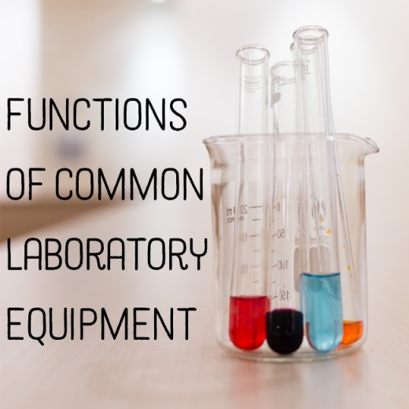

Functions of common pieces of laboratory equipment.

In most labs, you'll encounter the same basic apparatus. Here, the use for each is explained. You will learn about:

* Safety goggles and safety equipment
* Beakers
* Erlenmeyer flasks, AKA conical flasks
* Florence flasks, AKA boiling flasks
* Test tubes
* Watch glasses
* Crucibles
* Funnels
* Graduated cylinders
* Volumetric flasks
* Droppers
* Pipettes
* Burets
* Ring stands, rings, and clamps
* Tongs and forceps
* Spatulas and scoopulas
* Thermometers
* Bunsen Burners
* Balances

## Safety Goggles and Safety Equipment

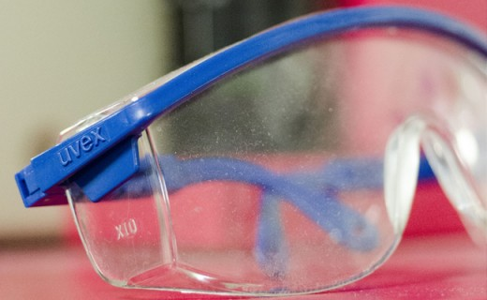

Safety goggles.

The first and foremost rule of any laboratory is to be safe! This may seem obvious, but people often disregard safety protocols for one reason or another, putting themselves and those around them in danger. The best thing you can do is to make sure you follow all safety protocols at all times.

Safety goggles are required wear in all chemistry labs. Not wearing them puts you in danger of eye irritation and possibly blindness in the case of an accident. A small droplet of acid could splash out of the container at any time. Better safe than permanently blinded!

Latex gloves should be used when there is a possibility of corrosive chemicals spilling onto your hands.

A lab apron or coat can also prevent injury in case of spills or splashes.

Never wear open-toed shoes or sandals in a lab.

## Beakers

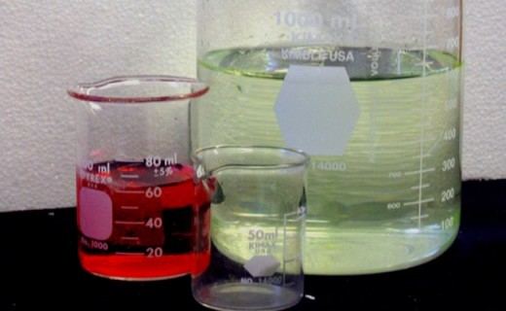

Beakers of various sizes.

A beaker is a common container in most labs. It is used for mixing, stirring, and heating chemicals. Most beakers have spouts on their rims to aid in pouring. They also commonly have lips around their rims and markings to measure the volume they contain, although they are not a precise way to measure liquids. Beakers come in a wide range of sizes.

Because of the lip that runs around the rim, a lid for a beaker does not exist. However, a watch glass can be used to cover the opening to prevent contamination or spl

## Erlenmeyer Flasks, AKA Conical Flasks

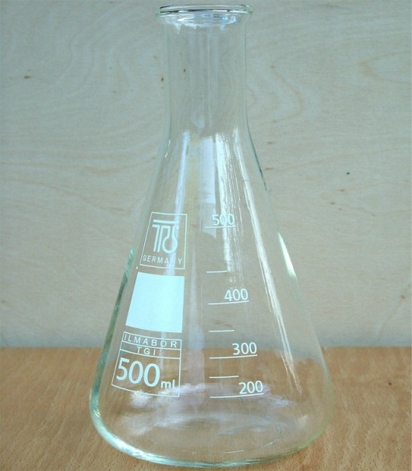

Erlenmeyer flask.

Also known as a conical flask, the Erlenmeyer flask was named after its inventor in 1861. It has a narrow neck and expands toward its base. This allows easy mixing and swirling of the flask without too much risk of spilling. The narrow opening also allows for the use of a rubber or glass stopper. It can easily be clamped to a ring stand as well as heated or shaken mechanically.

Once again the marks on the side are meant primarily for estimation rather than precision.

An important safety tip here is to never heat this flask while it is capped. This could cause a pressure build-up that could result in explosion.

## Florence Flasks, AKA Boiling Flasks

Also known as a boiling flask, the Florence flask has a round bottom and a long neck. It is used to hold liquids and can be easily swirled and heated. It can also easily be capped by rubber or glass stoppers.

Once again, safety dictates that this flask never be heated when capped. Pressure build-up and explosions can and do occur.

## Test Tubes

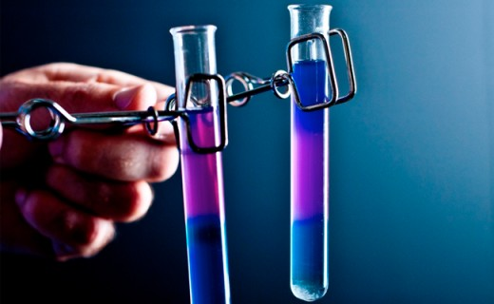

Test tubes held in spring clamps.

A test tube is a glass tube with one end open and the other end closed. The closed end is rounded. Test tubes are used to hold small samples. They are primarily used for qualitative assessment and comparison. A common place to see these is the biochemistry lab. When a large number of samples need to be tested and compared, test tubes are used to make this easier. They are also easily capped with a rubber or glass stopper.

They are generally held in a test tube rack specifically designed for the purpose. If heated or unsafe to touch with bare hands, test-tube tongs can be used to move them.

Never heat a capped test tube.

## Watch Glasses

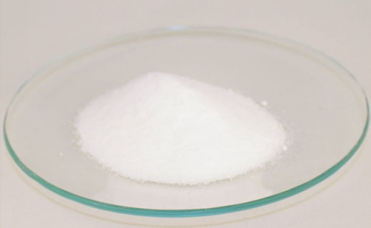

A watch glass holding a powder.

A watch glass is just a round piece of glass that is slightly concave/convex (think of a lens). It can hold a small amount of liquid or solid. They can be used for evaporation purposes and also can function as a lid for a beaker.

**CRUCIBLES:**

Crucibles

## A crucible is a small clay cup made of a material that can be heated to extreme temperatures. This is because they are used for heating. They come with lids.

## Funnels

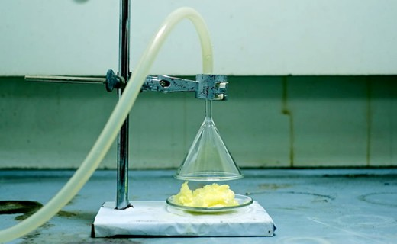

An inverted funnel positioned above a watch glass.

A lab funnel is just like any other funnel except that it was designed to be used in a laboratory setting. They can be made of plastic or glass and can have either a short stem or a long stem, depending on what they are needed for. There are several sizes that can be chosen from based on the amount of liquid that needs to go through them quickly.

Graduated Cylinders

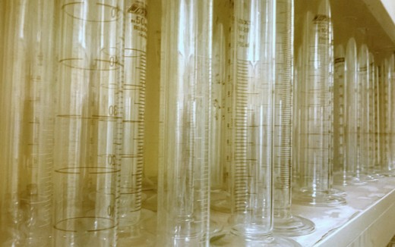

Graduated cylinders.

This is a primary measuring tool for the volume of a liquid. There are several markings up and down the length of the container with specific increments. Graduated cylinders come in many sizes. The smaller they are, the more specific the volume measurements will be.

When reading the volume from a graduated cylinder, you will notice that the liquid seems to have an indentation. The liquid around the edges will be higher than the liquid in the center, sloping down loke the sides of a trampoline when someone is standing in the middle. This is called the meniscus. Line the lowest point of the meniscus up with the nearest marking, keeping the cylinder level. That is how to properly read the volume.

## Volumetric Flasks

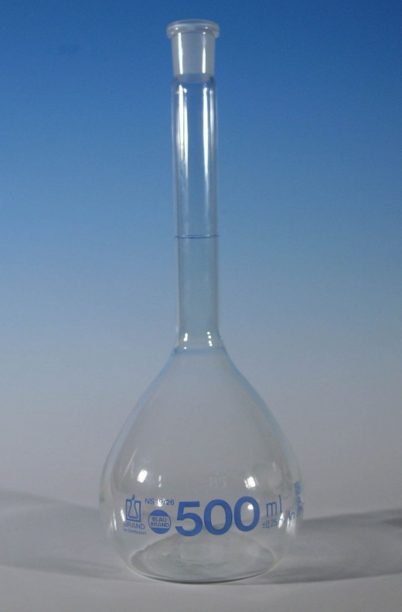

A 500-ml volumetric flask.

A volumetric flask is a round flask with a long neck and flat bottom. It is used to measure an exact volume of liquid. There is a small line on the neck that indicates how far to fill the bottle (Use the bottom of the meniscus). They come with special caps that will not let anything in or out.

Remember that temperature affects volume; therefore avoid using liquids that will fluctuate in temperature (hot water that will cool, for example).

**Droppers**

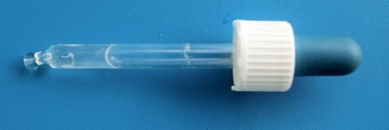

A glass dropper.

These are small glass tubes with narrow tips and a rubber bulb on the end. They suck up liquid that can then be squeezed out in small drops. These can be used to add an indicator to a solution about to be titrated.

## Pipettes

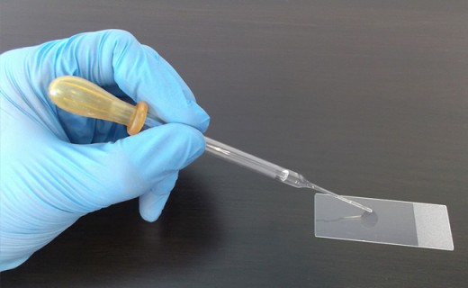

A Pasteur pipette.

There are a large variety of pipettes designed to accomplish specific goals. However, they are all for measuring an exact volume of liquid and placing it into another container.

**Buirets**

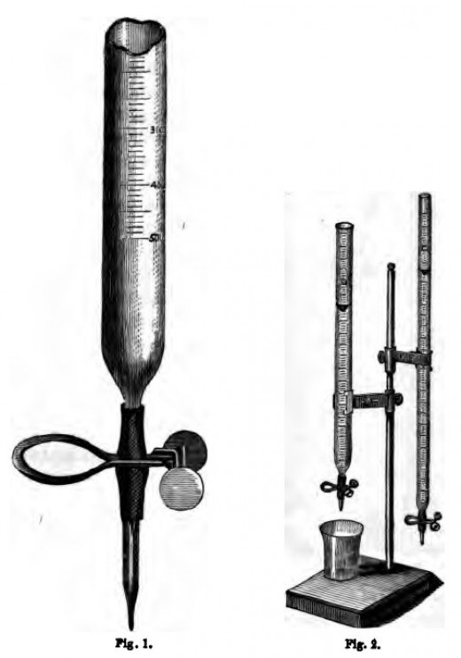

A Mohr burette.

A buret is a glass tube that is open at the top and comes to a narrow pointed opening at the bottom. Right above the bottom opening is a stopcock that can be turned to control the amount of liquid being released. There are markings along the length of the tube that indicate the volume of liquid present.

A buret is used for extremely accurate addition of liquid. By adjusting the stopcock, the amount of liquid that is released can be slowed to a drop every few seconds. Burets are one of the most accurate tools in the lab.

Burets are set up by using a buret clamp in combination with a ring stand, discussed below.

To determine how much liquid is added, write down how much is initially in the buret. Then when you're finished adding, write down how much is left. Subtract the final amount from the initial amount and you have the volume of liquid added.

Remember to measure from the bottom of the meniscus!

## Ring Stands, Rings, and Clamps

The ring stand is used to suspend burets, beakers, flasks, crucibles, etc. above other containers or in some cases a heat source (Bunsen burner, discussed below).

Always make sure everything is clamped to the stand tightly. When clamping glass, be careful not to shatter the glass. Only tighten that end until snug.

When using a ring on the stand, there are usually other pieces necessary to accomplish the goal. Wire mesh is laid across the ring to distribute evenly heat and support the beaker. A clay triangle with an open center is used to suspend crucibles.

Make sure everything is balanced! Do not let the whole setup tip over.

## Tongs and Forceps

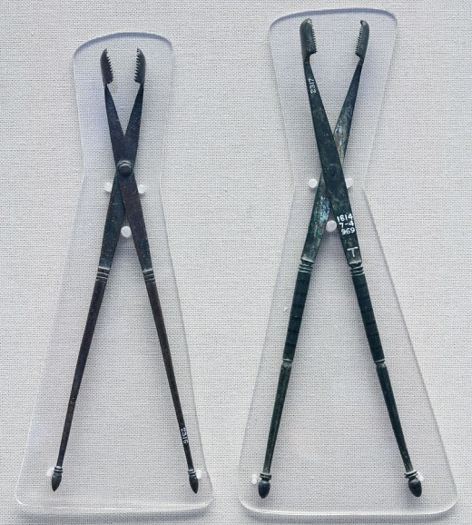

Foreceps.

Tongs and forceps are for grabbing things that should not be touched by hand. Some tongs are specially made to hold beakers, others to hold test tubes, and so on. There are also general tongs.

Forceps are used to grab small things like solid chemicals that are broken into chunks, so they can be safely handled and added to containers.

## Spatulas and Scoopulas

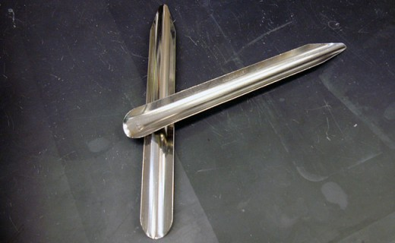

Two scoopulas.

Spatulas and scoopulas are for scooping solid chemicals. The typical use for these in a lab is scooping chemical out of its original container onto a weigh boat so that it can be weighed on a balance.

## Thermometers

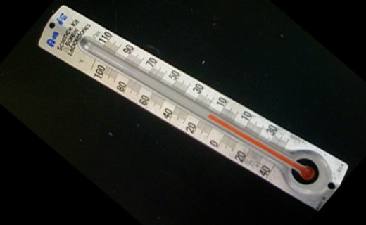

Glass thermometer

A laboratory thermometer is a glass thermometer used for measuring the temperature of liquids.

## Bunsen Burners

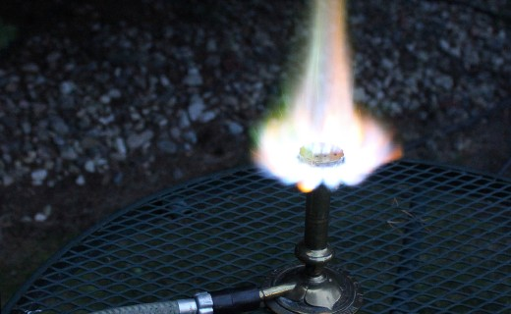

A lit Bunsen burner.

A Bunsen burner is a mechanical apparatus that is connected to a flammable gas source. There is a knob to adjust the amount of gas flow and a rotating collar that controls airflow. These both must be adjusted to get an ideal flame for heating purposes. The burner is lit with a striker.

Utmost safety is required when using a Bunsen burner.

## Balances

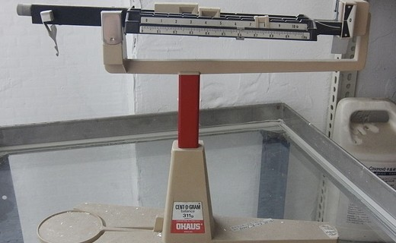

Triple beam balance.

A balance is used to weigh chemicals. The chemicals are always in some form of container and never placed directly on the balance. It is important not to move a balance because they have been calibrated for the exact position they are in. Some balances have plastic housing with small doors to keep air currents from affecting the measurement. Close these doors whenever the balance is in use.

To use a balance to determine the weight of a chemical, first put the empty container that the chemical will be in on the balance. Once you have a reading, press the "tare" or "zero" button on the balance. Remove the container from the balance and add the chemical (never add chemicals to a container while it is on the balance). Reweigh after adding the chemical to find the weight of only the chemical.

It is important to keep the balance clean.

**EVALUATION**

l. Which branch of pure chemistry deals with the study of compounds associated with non-living sources?

(a) Physical chemistry             (b) Organic chemistry

(c) Biochemistry                      (d) Inorganic chemistry

2. Which of the following is not a applied chemistry?

(a) Geochemistry         (b) Biochemistry

(c) Radiochemistry      (d) inorganic chemistry.

3. In order to design new drug, a chemist has to seek the help of

(a) Engineer                 (b) Geologist

(c) Zoologist               (d) Physician.

4. The branch of chemistry which deals with the study of hydrocarbons is called

(a) Organic chemistry              (c) Radiochemistry

(b) Inorganic chemistry           (d) Nuclear chemistry.

**II. Fill in the Blanks**

5. Complete the following sentences by supplying appropriate words:

(i) Ecologist and chemist work together to ….. .

(ii) The branch of pure chemistry which deals with study of fundamental laws and principles is called  …..

(iii) Qualitative analysis deals with  ….. .

(iv) Radiochemistry deals with the study of  …..  substances.

(v) The phenomenon of metamorphosis of rocks is studied by ….. branch of chemistry. m.

**Discussion Questions**

6. Define chemistry and its various disciplines.

7. Comment on the statement that chemistry is a central science discipline.

8. Write the names of various disciplines of applied chemistry. Define any two of them.

9. Name and define various branches of pure chemistry.

10. Give a brief account of various career options of degree holder in chemistry.

**WEEK 2**

**PARTICULATE NATURE OF MATTER**

In our daily life, we come across many objects, the knowledge about which can be gained by one or more of our senses like sight, touch, hearing, taste and smelling. These objects possess mass, occupy space and may have different shapes, sizes and colours. All these objects constitute matter. Matter may thus, be defined as anything that occupies space, possesses mass, offers resistance and can be felt by one or more of our senses. Some examples of matter are, water, air, metals, plants, animals, etc. Thus, matter has countless forms. The matter can be classified into different categories depending upon its physical or chemical nature. Matter is categorized as a gas, a liquid or a solid on the basis of physical state. Air is gas, water is liquid whereas sand is solid. Gases and liquids are fluids but solids are rigid.

On the basis of chemical nature matter is classified as an element, compound or mixture.

Elements and compounds are pure substances whereas mixtures contain two or more pure substances.

In this Unit, we shall study classification of matter on the basis of its physical properties.

**PARTICULATE NATURE OF MATTER**

* Matter is made up of small particles

The particle nature of matter can be demonstrated in activity 4.1:

**ACTIVITY4.1**

**To demonstrate particle nature of matter**

1. Take about 50 cm3 water in a 100 cm3 beaker.

2. Mark the level of water.

3. Add some sugar to the beaker and stir with the help of a glass rod.

4. Observe the change in water level.

Fig. 4.1. Dissolution of sugar in water. In solution particles of sugar are present in the spaces between particles of water

It is observed that the crystals of sugar disappear. The level of water remains unchanged. These observations can be explained by assuming that matter is made up of small particles. On dissolution, the particles of sugar get distributed into the spaces between particles of water.

• The constituent particles of matter are extremely small in size

The following activity demonstrates that the constituent particles of matter are very small

**ACTIVITY 4.2**

**To demonstrate that the particles of matter are very small**

1. Take a 250 cm3 beaker and add 100 cm3 water to it

2. Now add 2-3 crystals of KMnO4 and stir with a glass rod in order to dissolve the crystals.

3. Take 10 cm3 of this solution and add to 100 cm3 of water taken in another beaker.

4. Take 10 cm3 of this diluted solution and put into 100 cm3 of water taken in still another beaker.

5. Repeat this process 10 times. Observe the colour of the solution in the last beaker.

It is observed that the water in the last beaker is still coloured but the intensity of colour becomes light It indicates that KMnO4 crystal contains millions of tiny particles, some of which are still present even in the last beaker after so much dilution.

**• There are spaces between particles of matter** In activity 4.1 we observed that when sugar is dissolved in water, the volume of the liquid remains unchanged. During dissolution, the particles of sugar get into the spaces between the particles of water. As a result, they get evenly Distributed and there is no noticeable change in volume. Similarly, when KMnO4 is dissolved in water, its particles get evenly distributed throughout the bulk of water. This is indicated by uniform colour of the solution. This indicates that there are spaces between particles of matter. The particles of KMnO4 get uniformly distributed in the spaces between water molecules.

• The particles of matter are continuously moving The motion of particles of matter can be demonstrated by the following practical activities:

**ACTIVITY 4.3**

**To demonstrate motion of particles of matter**

Place a bottle containing concentrated aqueous solution of ammonia in a corner of the room. Remove the stopper.

What do you observe?

It is observed that ammoniacal smell can be sensed sitting at a distance.

It demonstrates that the particles of ammonia are moving. Due to this motion they are able to reach the observer.

Similarly, if an incense stick is lighted and placed in one comer of a room, its pleasant smell spreads in the whole room quickly. It demonstrates that the particles of matter possess motion. A burning incense stick produces some gases (vapour) having pleasant smell. The particles of these gases due to motion spread in the entire room and their presence can be felt by sensing the smell.

**ACTIVITY 4.4**

**To demonstrate motion of particles in water and ink**

1. Take a 250 cm3 beaker and add about 100 cm3 of water to it.

2. Put a drop of blue ink to the water taken in the beaker. What do you observe?

It is observed that the blue ink gets evenly distributed in the water.

This demonstrates that the particles of water and ink possess motion.

Due to motion of the particles, the particles of the two liquids are able to mix with each other.

**ACTIVITY 4.5**

**To demonstrate that the kinetic energy of particles increases with increase in temperature**

1. Take two beakers. To one beaker add 100 cm3 of cold water and to the other beaker add 1 00 cm3 of hot water.

2. Now add a crystal of potassium permanganate to both the beakers.

What do you observe?

It is observed that the purple colour of potassium permanganate starts spreading and after sometime the entire solution becomes purple. The rate of mixing is faster in case of hot water. This experiment demonstrates that the particles of matter possess motion and that the kinetic energy of the particles increases with increase in temperature

The above activities demonstrate that when two different forms of matter are brought in contact they intermix spontaneously. This intermixing is possible due to motion of the particles of matter and also due to the spaces between them. The intermixing takes place due to movement of particles of one form into the spaces between the particles of the other form of matter. This spontaneous intermixing of particles of two different types of matter is called diffusion. The rate of diffusion becomes faster with increase in temperature because at higher temperature, the particles have more energy and hence move faster.

**• Particles of matter attract each other**

There are forces of attraction between particles of matter. The evidence for forces of attraction in gases is obtained from the fact that they can be liquefied by applying pressure.

The important characteristics of particles of matter are summarized below:

1. The particles of matter are extremely small in size.

2. The particles of matter have spaces between them.

3. The particles of matter are continuously moving.

4. The particles of matter attract each other.

The constituent particles of matter may be atoms, molecules or ions. Some examples are given below in tabular form:

Constituent particles               Examples

1. Atoms                                 Argon, neon, helium, diamond

2. Molecules                            Sucrose , glucose,urea,methane carbon(IV) oxide

3. Ions                                     Sodium chloride, magnesium oxide, zinc sulphide

**STATES OF MATTER**

Matter can be classified into three categories depending upon its physical state, namely: solids, liquids and gases. These states of matter arise due to variation in the characteristics of the particles of matter.

**PROPERTIES OF SOLIDS**

(i) The matter in solid state possesses a definite volume, a definite shape, distinct boundaries and a definite mass.

(ii) Solids are rigid and almost incompressible.

(iii) Solids may break under force but it is difficult to change their shape.

(iv) Solids generally possess high densities.

(v) Solids do not exhibit diffusion. Some common examples are: table, chair, common salt, silver, ice, diamond, etc.

**PROPERTIES OF LIQUIDS**

(i) The matter in liquid state possesses a definite volume, a definite mass, but no definite shape.

(ii) Liquids are also almost incompressible but are not rigid. In fact, they can flow and acquire the shape of the container in which they are kept.

(iii) Liquids can undergo diffusion.

(iv) Liquids also have high densities but less than that of solids.

Some examples are: milk, water, alcohol, petrol, kerosene, fruit juices, etc.

**PROPERT ES OF GASES**

(i) The matter in gaseous state has neither definite volume nor definite shape but it has definite mass. It acquires the shape and volume of the container.

(ii) Gases are highly compressible. For example, natural gas in compressed form is used as fuel (Compressed Natural Gas-CNG) in internal combustion engines. Oxygen supplied to hospitals in cylinders is also in compressed form. Due to high compressibility large volumes of gas can be compressed into a small cylinder and transported easily.

(iii) The gases exhibit the property of diffusing very fast into other gases.

(iv) Gases exert pressure on the walls of the container in which they are stored.

(v) Gases have very low densities.

Some common examples of gases are: air, hydrogen  carbon(IV) oxide, hydrogen, sulphide, ammonia, oxygen, nitrogen, etc.

* **In solids,** the interparticle spaces are small. They have smaller amounts of energy than the same particles in the liquid and gaseous states. Consequently, the particles in solid state cannot overcome the strong forces of attraction which are holding them together. In solids, particles can only vibrate about fixed positions. Thus, particles in a solid have vibrational and rotational motion but no translational motion. Because of smaller interparticle spaces, solids are almost incompressible while due to absence of translational motion they are rigid.
* **In liquids,** interparticle spaces are somewhat larger than in solids and the particles have larger amounts of energy. The particles in liquids can overcome the interparticle forces between each other to some extent and hence can move freely. However, the intermolecular forces in liquids are strong enough to keep the particles within the bulk. The particles in liquid state possess vibrational, rotational and translational motion.

* In gases, the interparticle spaces are very large and the particle possess much larger amounts of energy than those in solids and liquids. The gas particles have sufficient energy to overcome the interparticle attractive forces almost completely. As a result the gas particles move rapidly and randomly into any space available to them. Thus, a gas fills completely the vessel in which it is kept. That is why gases have neither definite shape nor definite volume. Since particles in gaseous state are free to move, they collide with one another and also against walls of the container. The pressure of the gas is due to collisions of molecules against walls of the container.

* Solid and liquid states are known as condensed states of matter due to smaller interparticle spaces” and negligible compressibility.
* Liquids and gases are known as fluids because of their ability to flow and take the shape of container

**PLASMA STATE-The Fourth State of matter**

The matter in this state is in the form of ionized gas. It consists of neutral mixture of positive ions and unbound electrons. The matter exists in this state at temperatures in the range 10000°C to 15000°C. The matter in the sun and stars exists in plasma state. It is estimated that 99% of the matter in the universe exists in plasma state. Neon in neon lights is also in plasma state.

### Plasma

* [Plasma](http://chemistry.about.com/od/chemistryglossary/g/Plasma-Definition.htm) has neither a definite volume nor a definite shape.
* Plasma often is seen in ionized gases. Plasma is distinct from a gas because it possesses unique properties. Free electrical charges (not bound to atoms or ions) cause plasma to be electrically conductive. Plasma may be formed by heating and ionizing a gas.

A comparison of the characteristic properties of solids,  liquids and gases are given in Table 4.1.

**Table 4.1. Comparison of Characteristic Properties of Solids, Liquids and Gases**

Property                      Solids                          Liquids                        Gases

l.Sbape                        Definite                       Take the shape           Take the shape of

of the con                    the container by

tainer, but do               occupying whole

not necessarily             of the space avaoccupy

all of it.                        ilable to them.

2. Volume                   Definite                      Definite                      Take the volume

of the container.

3. Compre-                  Almost            nil                   Almost nil                   Very large.

ssibility

4. Fluidity or               Rigid                           Fluid                                        Fluid

Rigidity

5. Density                    Large                           Large                           Very small.

6. Diffusion                 Generally                    Diffuse slowly            Diffuse rapidly.

do not

diffuse

7. Free                         Any                             Only one free              No free surface.

Surfaces                      number of                               surface

free

surfaces

**Why Solids, Liquids and Gases Exhibit Different Properties?**

The properties of matter in the three states of matter are different because the characteristics of the particles vary in the three states of matter.

Now let us understand how the characteristics of particles vary in the three states of matter.

## **Changes in states**

|  |  |
| --- | --- |
| ***Chemical properties:*** | *Properties that do change tha chemical nature of matter* |

Examples of physical properties are: color, smell, freezing point, boiling point, melting point, infra-red spectrum, attraction (paramagnetic) or repulsion (diamagnetic) to magnets, opacity, viscosity and density. There are many more examples. Note that measuring each of these properties will not alter the basic nature of the substance.

Examples of chemical properties are: heat of combustion, reactivity with water, PH, and electromotive force.

The more properties we can identify for a substance, the better we know the nature of that substance. These properties can then help us model the substance and thus understand how this substance will behave under various conditions*.*

|  |
| --- |
| Physical and Chemical Properties |

All substances have properties that we can use to identify them. For example we can idenify a person by their face, their voice, height, finger prints, DNA etc.. The more of these properties that we can identify, the better we know the person. In a similar way matter has properties - and there are many of them. There are two basic types of properties that we can associate with matter. These properties are called Physical properties and Chemical properties:

|  |  |
| --- | --- |
| ***Physical properties:*** | *Properties that do not change the chemical nature of matter* |
| ***Chemical properties:*** | *Properties that do change tha chemical nature of matter* |

Examples of physical properties are: color, smell, freezing point, boiling point, melting point, infra-red spectrum, attraction (paramagnetic) or repulsion (diamagnetic) to magnets, opacity, viscosity and density. There are many more examples. Note that measuring each of these properties will not alter the basic nature of the substance.

Examples of chemical properties are: heat of combustion, reactivity with water, PH, and electromotive force.

The more properties we can identify for a substance, the better we know the nature of that substance. These properties can then help us model the substance and thus understand how this substance will behave under various conditions*.*

# Changing States of Matter

A material will change from one state or phase to another at specific combinations of temperature and surrounding pressure. Typically, the pressure is atmospheric pressure, so temperature is the determining factor to the change in state in thosecases.

Names such as boiling and freezing are given to the various changes in states of matter. The temperature of a material will increase until it reaches the point where the change takes place. It will stay at that temperature until that change is completed.

## **Changes in states**

**The states of matter are solid, liquid, gas and plasma. Since there is some debate on whether plasma should be classified as a state of matter and since it is not commonly experienced, we will not discuss its properties here.**

### **Order of changes**

**When heat is applied to a material, its change in state typically goes from solid to liquid to gas. There are some exceptions where the material will go directly from a solid to a gas.**

**When a material is cooled, its change in state typically goes from gas to liquid to solid. There are some exceptions where the material will go directly from a gas to asolid.**

### **Names of changes**

**Each change in the state of matter has a specific name.**

|  |  |  |
| --- | --- | --- |
| Start from: | Change to: | Name |
| **solid** | **liquid** | **melting** |
| **liquid** | **solid** | **freezing** |
| **liquid** | **gas** | **boiling** |
| **gas** | **liquid** | **condensation** |
| **solid** | **gas (skipping liquid phase)** | **sublimation** |
| **gas** | **solid (skipping liquid phase)** | **deposition** |

## **Change in temperature**

**When a material reaches the temperature at which a change in state occurs, the temperature will remain the same until all the energy is used to change the state.**

### **Melting**

**When a solid is heated, its temperature rises until it reaches its melting point. Any additional heat added to the material will not raise the temperature until all of the material is melted.**

**Thus, if you heat some ice, its temperature will rise until it reaches 0° C (32° F). Then the ice will stay at that temperature until all the ice is melted. The heat energy is used to melt the ice and not to raise the temperature. After the ice is melted, the temperature of the water will continue to rise as more heat is applied.**

### **Boiling**

**When a liquid is heated, its temperature rises until it reaches its boiling point. The temperature will then remain at that point until all of the liquid is boiled away.**

**For example, the temperature of a pot of water will increase until it reaches 100° C (212° F). It will stay there until all the water is boiled away. The temperature of the steam can then be increased.**

### **Cooling**

**Likewise, when a gas is cooled, its temperature will drop until it reaches the condensation point. Any additional cooling or heat loss will not lower the temperature until all of the gas is condensed into the liquid state.**

**Then the temperature of the liquid will continue to drop as more cooling is applied. Once the liquid reaches the freezing point, the temperature will remain at that point until all of the liquid is solidified. Then the temperature of the solid cancontinue to decrease.**

**Chemical Changes**

Chemical changes take place on the molecular level. A chemical change produces a [new substance](http://chemistry.about.com/od/chemistryglossary/g/Pure-Substance-Definition.htm). [Examples of chemical changes](http://chemistry.about.com/od/generalchemistry/ss/11th-Grade-Chemistry-Notes-And-Review_2.htm) include combustion (burning), cooking an egg, rusting of an iron pan, and mixing [hydrochloric acid](http://chemistry.about.com/od/acidsbases/ig/Acids---Structures/Hydrochloric-Acid.-Qsg.htm) and [sodium hydroxide](http://chemistry.about.com/od/labrecipes/a/sodiumhydroxidesolutions.htm) to make salt and water.

**Physical Changes**

Physical changes are concerned with energy and states of matter.

A physical change does not produce a new substance. Changes in state or phase (melting, freezing, vaporization, condensation, sublimation) are physical changes. Examples of [physical changes](http://chemistry.about.com/od/chemistryglossary/g/physical-change-definition.htm) include crushing a can, [melting an ice](http://chemistry.about.com/od/howthingswork/f/ice-melt-faster-water-air.htm) cube, and breaking a bottle.

**How to Tell Chemical & Physical Changes Apart**

A [chemical change](http://chemistry.about.com/od/chemistryglossary/g/Chemical-Change-Definition.htm) makes a substance that wasn't there before. There may be [clues that a chemical reaction](http://chemistry.about.com/od/chemicalreactions/f/What-Is-A-Chemical-Reaction.htm) took place, such as light, heat, color change, gas production, odor, or sound. The starting and ending materials of a physical change are the same, even though they may look different.

### Examples of Chemical Changes

* burning wood
* dissolving salt in water
* [mixing acid](http://chemistry.about.com/od/labsafety/fl/Do-You-Add-Acid-to-Water-or-Water-to-Acid.htm) and base
* digesting food

### Examples of Physical Changes

* *crumpling a sheet of paper*
* *melting an ice cube*
* *casting silver in a mold*
* *breaking a bottle*

### How to Tell?

Look [for an indication that a chemical change](http://chemistry.about.com/od/chemistryglossary/g/Chemical-Change-Definition.htm) occurred. Chemical reactions release or absorb heat or other energy or may produce a gas, odor, color or sound. If you don't see any of these indications, a physical change likely occurred.

In some cases, it may be hard to tell whether a chemical or physical change occurred. For example, when you dissolve [sugar in water](http://chemistry.about.com/od/matter/f/Is-Dissolving-Sugar-In-Water-A-Chemical-Or-Physical-Change.htm), a [physical change](http://chemistry.about.com/od/chemistryglossary/g/physical-change-definition.htm) occurs. The form of the sugar changes, but it remains the same chemically (sucrose molecules). However, when you dissolve [salt in water](http://chemistry.about.com/od/waterchemistry/fl/What-Is-the-Most-Abundant-Salt-in-the-Sea.htm) the salt dissociates into its ions (from NaCl into Na+ and Cl-) [so a chemical change](http://chemistry.about.com/od/matter/a/Is-Dissolving-Salt-In-Water-A-Chemical-Change-Or-Physical-Change.htm) occurs. In both cases a white solid dissolves into a clear liquid and in both cases you can recover the starting material by removing the water, yet the processes are not the same.

# Difference between chemical and physical change

|  |  |
| --- | --- |
| http://antoine.frostburg.edu/chem/senese/images/dot.gif |  |
|  |  |

**Chemical change** is any change that results in the formation of new chemical substances. At the molecular level, chemical change involves making or breaking of bonds between atoms. These changes are chemical:

* iron rusting (iron oxide forms)
* gasoline burning (water vapor and carbon dioxide form)
* eggs cooking (fluid protein molecules uncoil and crosslink to form a network)
* bread rising (yeast converts carbohydrates into carbon dioxide gas)
* milk souring (sour-tasting lactic acid is produced)
* suntanning (vitamin D and melanin is produced)

**Physical change** rearranges molecules but doesn't affect their internal structures. Some examples of physical change are:

* whipping egg whites (air is forced into the fluid, but no new substance is produced)
* magnetizing a compass needle (there is realignment of groups ("domains") of iron atoms, but no real change within the iron atoms themselves).
* boiling water (water molecules are forced away from each other when the liquid changes to vapor, but the molecules are still H2O.)
* dissolving sugar in water (sugar molecules are dispersed within the water, but the individual sugar molecules are unchanged.) dicing potatoes (cutting usually separates molecules without changing them.)

SUMMARY

* Matter is anything that occupies space and has mass.
* Matter can be classified as solids, liquids and gases on the basis of its physical state.
* Matter is made up of extremely small particles.
* There are spaces between particles of matter.
* The particles of matter are continuously moving.
* The particles of matter attract each other.
* The spaces between particles are minimum in solid state and maximum in gases.
* The kinetic energy of particles minimum in solid state and maximum in gaseous state.
* The force of attraction between particles is maximum in solid state and negligible in gaseous state.
* Liquids and gases exhibit diffusion because their particles possess translatory motion and possess larger interparticle spaces.
* Solid and liquid states are known as condensed states of matter due to smaller interparticle spaces and very little compressibility.
* Liquids and gases are known as fluids because of their ability to flow and take the shape of the container.

**EVALUATION**

1.Which of the following is not an example of matter?

(a) Air                          (b) Almonds

(c) Cold-drink             (d) Love.

2. Which of the following has the strongest interparticle forces?

(a) Nitrogen                 (b) Water

(c) Iron                        d) Neon.

3 Which of the following has atoms as the constituent particles?

(a) Dry ice                   (b) Argon

(c) Glucose                  (d) Potassium chloride.

Fill in the blanks

Complete the following sentences by supplying appropriate words:

(i) The particles in …… state do not possess translator motion.

(ii) …… and …… states of matter are known as fluid states of matter.

(iii) Particles in …… state possess maximum kinetic energy.

(iv) Kinetic energy of particles of matter …… with increase in temperature.

**I .Discussion Question**

5 What are the characteristics of the particles of matter?

6. Which out of iron and chalk has stronger interparticle forces?

7. Give reasons for the following observations:

We can get the smell of perfume sitting from several meters away.

8. A diver is able to cut through water in a swimming pool. Which property of matter does this observation show?

9. Describe an activity to demonstrate that the matter consists of particles and that the particles are of extremely small size.

10. What are the characteristics of matter in solid state?

11.P Explain why:

(i) Solids do not undergo diffusion whereas liquids and gases undergo diffusion readily.

(ii) Gases are highly compressible.

12. Give reasons for the following:

(i) A gas fills completely the vessel in which it is kept.

(ii) A gas exerts pressure on the walls of the container.

11. Explain why solid and liquid states are known as condensed states of matter.

14. Give reasons:

(i) Sponge is a solid yet we are able to compress it.

(ii) Sugar when kept in jars of different shapes it takes the shape of the jar yet we call it a solid.

15.With two examples in each case,mention physical and chemical processes in your environment.

16.What are states of matter?Use a suitable diagram to show how one state can be converted to another state.

|  |  |  |  |  |  |  |  |  |  |  |  |  |  |  |  |  |  |  |  |  |  |  |  |  |  |  |  |  |  |  |  |  |  |  |  |  |  |  |  |  |  |  |  |  |  |  |  |  |  |  |  |  |  |  |  |  |  |  |  |  |  |  |  |  |  |  |  |  |  |  |  |  |  |  |  |  |  |  |  |  |  |  |  |  |  |  |  |  |  |  |  |  |  |  |  |  |  |  |  |  |  |  |  |  |  |  |  |  |  |  |  |  |  |  |  |  |  |  |  |  |  |  |  |  |  |  |  |  |  |  |  |  |  |  |  |  |  |  |  |  |  |  |  |  |  |  |  |  |  |  |  |  |  |  |  |  |  |  |  |  |  |  |  |  |  |  |  |  |  |  |  |  |  |  |  |  |  |  |  |  |  |  |  |  |  |  |  |  |  |  |  |  |  |  |  |  |  |  |  |  |  |  |  |  |  |  |  |  |  |  |  |  |  |  |  |  |  |  |  |  |  |  |  |  |  |  |  |  |  |  |  |  |  |  |  |  |  |  |  |  |  |  |  |  |  |  |  |  |  |  |  |  |  |  |  |  |  |  |  |  |  |  |  |  |  |  |  |  |  |  |  |  |  |  |  |  |  |  |  |  |  |  |  |  |  |  |  |  |  |  |  |  |  |  |  |  |  |  |  |  |  |  |  |  |  |  |  |  |  |  |  |  |  |  |  |  |  |  |  |  |  |  |  |  |  |  |  |  |  |  |  |  |  |  |  |  |  |  |  |  |  |  |  |  |  |  |  |  |  |  |  |  |  |  |  |  |  |  |  |  |  |  |
| --- | --- | --- | --- | --- | --- | --- | --- | --- | --- | --- | --- | --- | --- | --- | --- | --- | --- | --- | --- | --- | --- | --- | --- | --- | --- | --- | --- | --- | --- | --- | --- | --- | --- | --- | --- | --- | --- | --- | --- | --- | --- | --- | --- | --- | --- | --- | --- | --- | --- | --- | --- | --- | --- | --- | --- | --- | --- | --- | --- | --- | --- | --- | --- | --- | --- | --- | --- | --- | --- | --- | --- | --- | --- | --- | --- | --- | --- | --- | --- | --- | --- | --- | --- | --- | --- | --- | --- | --- | --- | --- | --- | --- | --- | --- | --- | --- | --- | --- | --- | --- | --- | --- | --- | --- | --- | --- | --- | --- | --- | --- | --- | --- | --- | --- | --- | --- | --- | --- | --- | --- | --- | --- | --- | --- | --- | --- | --- | --- | --- | --- | --- | --- | --- | --- | --- | --- | --- | --- | --- | --- | --- | --- | --- | --- | --- | --- | --- | --- | --- | --- | --- | --- | --- | --- | --- | --- | --- | --- | --- | --- | --- | --- | --- | --- | --- | --- | --- | --- | --- | --- | --- | --- | --- | --- | --- | --- | --- | --- | --- | --- | --- | --- | --- | --- | --- | --- | --- | --- | --- | --- | --- | --- | --- | --- | --- | --- | --- | --- | --- | --- | --- | --- | --- | --- | --- | --- | --- | --- | --- | --- | --- | --- | --- | --- | --- | --- | --- | --- | --- | --- | --- | --- | --- | --- | --- | --- | --- | --- | --- | --- | --- | --- | --- | --- | --- | --- | --- | --- | --- | --- | --- | --- | --- | --- | --- | --- | --- | --- | --- | --- | --- | --- | --- | --- | --- | --- | --- | --- | --- | --- | --- | --- | --- | --- | --- | --- | --- | --- | --- | --- | --- | --- | --- | --- | --- | --- | --- | --- | --- | --- | --- | --- | --- | --- | --- | --- | --- | --- | --- | --- | --- | --- | --- | --- | --- | --- | --- | --- | --- | --- | --- | --- | --- | --- | --- | --- | --- | --- | --- | --- | --- | --- | --- | --- | --- | --- | --- | --- | --- | --- | --- | --- | --- | --- | --- | --- | --- | --- | --- | --- | --- | --- | --- | --- | --- | --- | --- | --- | --- | --- | --- | --- | --- | --- | --- | --- | --- | --- | --- | --- | --- | --- | --- | --- | --- | --- | --- | --- | --- | --- | --- | --- |
| ***W*** | **WEEK 3.**  **ELEMENTS**  **Element Definition:** A chemical element is a substance that cannot be broken down by chemical means. Elements are defined by the number of [protons](http://chemistry.about.com/od/chemistryglossary/a/protondef.htm) they possess.  These are the first 20 elements, listed in order:  1 - H - Hydrogen 2 - He - Helium 3 - Li - Lithium 4 - Be - Beryllium 5 - B - Boron 6 - C - Carbon 7 - N - Nitrogen 8 - O - Oxygen 9 - F - Fluorine 10 - Ne - Neon 11 - Na - Sodium 12 - Mg - Magnesium 13 - Al - Aluminum 14 - Si - Silicon 15 - P - Phosphorus 16 - S - Sulfur 17 - Cl - Chlorine 18 - Ar - Argon 19 - K - Potassium 20 - Ca - Calcium  States of Matter - Elements The states of matter of all of the elements is given for normal conditions, i.e. a temperature of 20°C. The 3 states of matter are either solid, liquid or gas. Most elements are solids, only 11 are gases and 2 are liquids.    *Structure of an atom*  Atoms are the basic units of matter and the defining structure of elements. Atoms are made up of three particles: protons, neutrons and electrons.  Protons and neutrons are heavier than electrons and reside in the center of the atom, which is called the nucleus. Electrons are extremely lightweight and exist in a cloud orbiting the nucleus. The electron cloud has a radius 10,000 times greater than the nucleus.  Protons and neutrons have approximately the same mass. However, one proton weighs more than 1,800 electrons. Atoms always have an equal number of protons and electrons, and the number of protons and neutrons is usually the same as well. Adding a proton to an atom makes a new element, while adding a neutron makes an isotope, or heavier version, of that atom. Nucleus The nucleus was discovered in 1911, but its parts were not identified until 1932. Virtually all the mass of the atom resides in the nucleus. The nucleus is held together by the "strong force," one of the four basic forces in nature. This force between the protons and neutrons overcomes the repulsive electrical force that would, according to the rules of electricity, push the protons apart otherwise. Protons Protons are positively charged particles found within atomic nuclei. They were discovered by Ernest Rutherford in experiments conducted between 1911 and 1919.  The number of protons in an atom defines what element it is. For example, [carbon](http://www.livescience.com/28698-facts-about-carbon.html) atoms have six protons, [hydrogen](http://www.livescience.com/28466-hydrogen.html) atoms have one and [oxygen](http://www.livescience.com/28738-oxygen.html) atoms have eight. The number of protons in an atom is referred to as the atomic number of that element. The number of protons in an atom also determines the chemical behavior of the element. The [Periodic Table of the Elements](http://www.livescience.com/25300-periodic-table.html) arranges elements in order of increasing atomic number.  Protons are made of other particles called quarks. There are three quarks in each proton — two "up" quarks and one "down" quark — and they are held together by other particles called gluons. Electrons Electrons have a negative charge and are electrically attracted to the positively charged protons. Electrons surround the atomic nucleus in pathways called orbitals. The inner orbitals surrounding the atom are spherical but the outer orbitals are much more complicated.  An atom's electron configuration is the orbital description of the locations of the electrons in an unexcited atom. Using the electron configuration and principles of physics, chemists can predict an atom's properties, such as stability, boiling point and conductivity.  Typically, only the outermost electron shells matter in chemistry. The inner electron shell notation is often truncated by replacing the long-hand orbital description with the symbol for a noble gas in brackets. This method of notation vastly simplifies the description for large molecules.  For example, the electron configuration for [beryllium](http://www.livescience.com/28641-beryllium.html) (Be) is 1s22s2, but it's is written [He]2s2. [He] is equivalent to all the electron orbitals in a [helium](http://www.livescience.com/28552-facts-about-helium.html) atom. The Letters, s, p, d, and f designate the shape of the orbitals and the superscript gives the number of electrons in thatorbital. Neutrons Neutrons are uncharged particles found within atomic nuclei. A neutron's mass is slightly larger than that of a proton. Like protons, neutrons are also made of quarks — one "up" quark and two "down" quarks. Neutrons were discovered by James Chadwick in 1932.  The **mass number** (**A**), also called **atomic mass number** or **nucleon number**, is the total number of [protons](https://en.wikipedia.org/wiki/Proton) and [neutrons](https://en.wikipedia.org/wiki/Neutron) (together known as [nucleons](https://en.wikipedia.org/wiki/Nucleon)) in an [atomic nucleus](https://en.wikipedia.org/wiki/Atomic_nucleus). It determines the [atomic mass](https://en.wikipedia.org/wiki/Atomic_mass) of [atoms](https://en.wikipedia.org/wiki/Atom). Because protons and neutrons both are [baryons](https://en.wikipedia.org/wiki/Baryon), the mass number A is identical with the [baryon number](https://en.wikipedia.org/wiki/Baryon_number) B as of the nucleus as of the whole [atom](https://en.wikipedia.org/wiki/Atom) or [ion](https://en.wikipedia.org/wiki/Ion). The mass number is different for each different [isotope](https://en.wikipedia.org/wiki/Isotope) of a [chemical element](https://en.wikipedia.org/wiki/Chemical_element). This is not the same as the [atomic number](https://en.wikipedia.org/wiki/Atomic_number) (**Z**) which denotes the number of protons in a nucleus, and thus uniquely identifies an element. Hence, the difference between the mass number and the atomic number gives the [number of neutrons](https://en.wikipedia.org/wiki/Neutron_number) (N) in a given nucleus: N=A−Z.[[1]](https://en.wikipedia.org/wiki/Mass_number#cite_note-1)  The mass number is written either after the element name or as a superscript to the left of an element's symbol. For example, the most common isotope of [carbon](https://en.wikipedia.org/wiki/Carbon) is [carbon-12](https://en.wikipedia.org/wiki/Carbon-12), or 12C, which has 6 protons and 6 neutrons. The full isotope symbol would also have the atomic number (**Z**) as a subscript to the left of the element symbol directly below the mass number: 12 6C.[[2]](https://en.wikipedia.org/wiki/Mass_number#cite_note-2) This is technically redundant, as each element is defined by its atomic number, so it is often omitted  The **atomic number** of a [chemical element](https://en.wikipedia.org/wiki/Chemical_element) (also known as its **proton number**) is the number of [protons](https://en.wikipedia.org/wiki/Proton) found in the [nucleus](https://en.wikipedia.org/wiki/Atomic_nucleus) of an [atom](https://en.wikipedia.org/wiki/Atom) of that element, and therefore identical to the [charge number](https://en.wikipedia.org/wiki/Charge_number) of the nucleus. It is conventionally represented by the symbol **Z**. The atomic number uniquely identifies a chemical element. In an [uncharged](https://en.wikipedia.org/wiki/Electric_charge) atom, the atomic number is also equal to the number of [electrons](https://en.wikipedia.org/wiki/Electron).  **EVALUATION**  **1.Write the symbols of the first twenty elements.**  **2.Classify the first twenty elements into the three states of matter.**  **3.Define atomic number and mass number.**  **WEEK 4.**  **MOLECULES AND ATOMICITY**  A molecule is the smallest particle in a chemical [element](http://whatis.techtarget.com/definition/element) or [compound](http://whatis.techtarget.com/definition/compound) that has the chemical properties of that element or compound. Molecules are made up of [atom](http://searchcio-midmarket.techtarget.com/definition/atom) s that are held together by chemical bonds. These bonds form as a result of the sharing or exchange of [electron](http://searchcio-midmarket.techtarget.com/definition/electron) s among atoms.  The atoms of certain elements readily bond with other atoms to form molecules. Examples of such elements are oxygen and chlorine. The atoms of some elements do not easily bond with other atoms. Examples are neon and argon.  Molecules can vary greatly in size and complexity. The element helium is a one-atom molecule. Some molecules consist of two atoms of the same element. For example, O 2 is the oxygen molecule most commonly found in the earth's atmosphere; it has two atoms of oxygen. However, under certain circumstances, oxygen atoms bond into triplets (O 3 ), forming a molecule known as ozone. Other familiar molecules include water, consisting of two hydrogen atoms and one oxygen atom (H 2 O), carbon dioxide, consisting of one carbon atom bonded to two oxygen atoms (CO 2 ), and sulfuric acid, consisting of two hydrogen atoms, one sulfur atom, and four oxygen atoms (H 2 SO 4 ).  ATOMICITY OF ELEMENTS.  1.MONOATOMIC ELEMETS:these are elements with only one atom e.gthe noble gases(neon,argon,helium),sodium magnesium, in short all metals are monoatomic.  2.DIATOMIC ELEMENTS:these elements contains two atoms .most non metals fall under this category.e.g N2.F2.Cl2,O2,Br2.I2.H2.  3.POLYATOMIC ELEMENTS: are those elements with more than two atoms.e.g phosphorus 5,sulphur 8  **Foundations of Dalton's atomic theory**   |  |  | | --- | --- | | http://antoine.frostburg.edu/chem/senese/images/dot.gif |  | |  |  |   Dalton's atomic theory makes the following assumptions:   1. **All matter consists of tiny particles.** The existence of atoms was first suggested more that 2000 years before Dalton's birth. Atoms remained pure speculation through most of this time, although Newton used arguments based on atoms to explain the gas laws in 1687. (Newton's speculations about atoms in the *Principia* were carefully copied by hand into Dalton's notebooks.) 2. **Atoms are indestructible and unchangeable.** Atoms of an element cannot be created, destroyed, broken into smaller parts or transformed into atoms of another element. Dalton based this hypothesis on the law of conservation of mass and on centuries of experimental evidence.   With the discovery of subatomic particles after Dalton's time, it became apparent that atoms could be broken into smaller parts. The discovery of nuclear processes showed that it was even possible to transform atoms from one element into atoms of another. But we don't consider processes that affect the nucleus to be chemical processes. The postulate is still useful in explaining the law of conservation of mass in chemistry. A slightly more restrictive wording is "Atoms cannot be created, destroyed, or transformed into other atoms in a chemical change".   |  | | --- | |  | |  |  1. **Elements are characterized by the mass of their atoms.** All atoms of the same element have identical weights, Dalton asserted. Atoms of different elements have different weights. (Dalton used the word "weight" rather than mass, and chemists have called atomic masses "atomic weights" ever since).   We now know that atoms of the same element sometimes have slightly different masses, but always have identical nuclear charge. In modern atomic theory, the postulate has been amended to read: "Elements are characterized by the nuclear charge of their atoms".   1. **When elements react, their atoms combine in simple, whole-number ratios.** This postulate suggested a practical strategy for determining relative atomic weights from elemental percentages in compounds. Experimental atomic weights could then be used to explain the fixed mass percentages of elements in all compounds of those elements!   By suggesting that compounds contained characteristic atom-to-atom ratios, Dalton effectively explained the law of definite proportions.   1. **When elements react, their atoms sometimes combine in more than one simple, whole-number ratio.** Dalton used this postulate to explain why the weight ratios of nitrogen to oxygen in various nitrogen oxides were themselves simple multiples of each other. Even Dalton's critics were impressed by the power and simplicity of his explanation, and it persuaded many of them that his atomic theory was worthy of further investigation.   Unfortunately, Dalton included an additional postulate that prevented his theory from being accepted for many years. When atoms combine in only one ratio, Dalton said, "..it must be presumed to be a *binary* one, unless some cause appear to the contrary" [[2](http://antoine.frostburg.edu/chem/senese/101/atoms/dalton-links.shtml#2)]. He had no experimental evidence to support this postulate, and it lead him to mistakenly assume that the formula of water was OH and the formula of ammonia was NH. As a result, Dalton's atomic weights for oxygen and nitrogen were incorrect and his experimental data did not support many of the conclusions he drew from it.A consistent set of atomic weights was absolutely essential before the theory could be accepted and applied. Next, we'll see how Dalton's postulates can be used to estimate atomic weights from experimental data, and how they explain three basic laws of chemistry.  **EVALUATION**  **1.Define molecules and Atomicity.**  **2.State with examples, the types of Atomicity.**  **3.State Dalton’s Atomic theory. Describe its modification**  **WEEK 5**  PARTICULATE NATURE OF MATTER  Structure of an atom  Atoms are the basic units of matter and the defining structure of elements. Atoms are made up of three particles: protons, neutrons and electrons.  Protons and neutrons are heavier than electrons and reside in the center of the atom, which is called the nucleus. Electrons are extremely lightweight and exist in a cloud orbiting the nucleus. The electron cloud has a radius 10,000 times greater than the nucleus.  Protons and neutrons have approximately the same mass. However, one proton weighs more than 1,800 electrons. Atoms always have an equal number of protons and electrons, and the number of protons and neutrons is usually the same as well. Adding a proton to an atom makes a new element, while adding a neutron makes an isotope, or heavier version, of that atom. Nucleus The nucleus was discovered in 1911, but its parts were not identified until 1932. Virtually all the mass of the atom resides in the nucleus. The nucleus is held together by the "strong force," one of the four basic forces in nature. This force between the protons and neutrons overcomes the repulsive electrical force that would, according to the rules of electricity, push the protons apart otherwise. Protons Protons are positively charged particles found within atomic nuclei. They were discovered by Ernest Rutherford in experiments conducted between 1911 and 1919.  The number of protons in an atom defines what element it is. For example, [carbon](http://www.livescience.com/28698-facts-about-carbon.html) atoms have six protons, [hydrogen](http://www.livescience.com/28466-hydrogen.html) atoms have one and [oxygen](http://www.livescience.com/28738-oxygen.html) atoms have eight. The number of protons in an atom is referred to as the atomic number of that element. The number of protons in an atom also determines the chemical behavior of the element. The [Periodic Table of the Elements](http://www.livescience.com/25300-periodic-table.html) arranges elements in order of increasing atomic number.  Protons are made of other particles called quarks. There are three quarks in each proton — two "up" quarks and one "down" quark — and they are held together by other particles called gluons. Electrons Electrons have a negative charge and are electrically attracted to the positively charged protons. Electrons surround the atomic nucleus in pathways called orbitals. The inner orbitals surrounding the atom are spherical but the outer orbitals are much more complicated.  An atom's electron configuration is the orbital description of the locations of the electrons in an unexcited atom. Using the electron configuration and principles of physics, chemists can predict an atom's properties, such as stability, boiling point and conductivity.  Typically, only the outermost electron shells matter in chemistry. The inner electron shell notation is often truncated by replacing the long-hand orbital description with the symbol for a noble gas in brackets. This method of notation vastly simplifies the description for large molecules.  For example, the electron configuration for [beryllium](http://www.livescience.com/28641-beryllium.html) (Be) is 1s22s2, but it's is written [He]2s2. [He] is equivalent to all the electron orbitals in a [helium](http://www.livescience.com/28552-facts-about-helium.html) atom. The Letters, s, p, d, and f designate the shape of the orbitals and the superscript gives the number of electrons in that orbital. Neutrons Neutrons are uncharged particles found within atomic nuclei. A neutron's mass is slightly larger than that of a proton. Like protons, neutrons are also made of quarks — one "up" quark and two "down" quarks. Neutrons were discovered by James Chadwick in 1932.  **RULES FOR FILLING ORBITALS**  **Rule 1** - Lowest energy orbitals fill first. Thus, the filling pattern is **1s**, **2s**, **2p**, **3s**, **3p**, **4s**, **3d**, etc. Since the orbitals within a subshell are degenerate (of equal energy), the entire subshell of a particular orbital type is filled before moving to the next subshell of higher energy.  **Rule 2** - Pauli Exclusion Principle - Only two electrons are permitted per orbital and they must be of opposite spin. If one electron within an orbital possesses a clockwise spin, then the second electron within that orbital will possess a counterclockwise spin. Two electrons with opposite spins found in the same orbital are referred to as being paired.  **Rule 3**- Hund's Rule - The most stable arrangement of electrons in a subshell occurs when the maximum number of unpaired electrons exist, all possessing the same spin direction. This occurs due to the degeneracy of the orbitals, all orbitals within a subshell are of equal energy. Electrons are repulsive to one another and only pair after all of the orbitals have been singly filled. Rules for Assigning Electron OrbitalsOccupation of Orbitals Electrons fill orbitals in a way to minimize the energy of the atom. Therefore, the electrons in an atom fill the principal energy levels in order of increasing energy (the electrons are getting farther from the nucleus). The order of levels filled looks like this:  1s, 2s, 2p, 3s, 3p, 4s, 3d, 4p, 5s, 4d, 5p, 6s, 4f, 5d, 6p, 7s, 5f, 6d, and 7p  One way to remember this pattern, probably the easiest, is to refer to the periodic table and remember where each orbital block falls to logically deduce this pattern. Another way is to make a table like the one below and use vertical lines to determine which subshells correspond with each other.  subshells.jpg Pauli Exclusion Principle The [Pauli exclusion principle](http://chemwiki.ucdavis.edu/Inorganic_Chemistry/Electronic_Configurations/Pauli_Exclusion_Principle) states that no two electrons can have the same four quantum numbers. The first three (n, l, and ml) may be the same, but the fourth [quantum number](http://chemwiki.ucdavis.edu/Physical_Chemistry/Quantum_Mechanics/10%3A_Multi-electron_Atoms/Quantum_Numbers) must be different. A single orbital can hold a maximum of two electrons, which **must** have opposing spins; otherwise they would have the same four quantum numbers, which is forbidden. One electron is spin up (ms = +1/2) and the other would spin down (ms = -1/2). This tells us that each subshell has double the electrons per orbital. The s subshell has 1 orbital that can hold up to 2 electrons, the p subshell has 3 orbitals that can hold up to 6 electrons, the d subshell has 5 orbitals that hold up to 10 electrons, and the f subshell has 7 orbitals with 14 electrons.  Example 1: Hydrogen and Helium  The first three quantum numbers of an electron are n=1, l=0, ml=0. Only two electrons can correspond to these, which would be either ms = -1/2 or ms = +1/2. As we already know from our studies of quantum numbers and electron orbitals, we can conclude that these four quantum numbers refer to the 1s subshell. If only one of the ms values are given then we would have 1s1 (denoting hydrogen) if both are given we would have 1s2(denoting helium). Visually, this is be represented as: Hund's Rule When assigning electrons in orbitals, each electron will first fill all the orbitals with similar energy (also referred to as degenerate) before pairing with another electron in a half-filled orbital. Atoms at ground states tend to have as many unpaired electrons as possible. When visualizing this processes, think about how electrons are exhibiting the same behavior as the same poles on a magnet would if they came into contact; as the negatively charged electrons fill orbitals they first try to get as far as possible from each other before having to pair up.  Example 2: Oxygen and Nitrogen  If we look at the correct electron configuration of the [Nitrogen](http://chemwiki.ucdavis.edu/Physical_Chemistry/Quantum_Mechanics/11%3A_Molecules/Virtual%3A_Molecular_Orbitals/Molecular_Orbital_Diagrams/Nitrogen) (Z = 7) atom, a very important element in the biology of plants: 1s2 2s2 2p3  Nitrogenexample.jpg  We can clearly see that p orbitals are half-filled as there are three electrons and three p orbitals. This is because Hund's Rule states that the three electrons in the 2p subshell will fill all the empty orbitals first before filling orbitals with electrons in them. If we look at the element after Nitrogen in the same period, [Oxygen](http://chemwiki.ucdavis.edu/Development_Details/Approaches/VVV_Demos/Additional_Demos/The_Chemistry_of_Oxygen) (Z = 8) its electron configuration is: 1s2 2s2 2p4 (for an atom).  oxygenexample.jpg  Oxygen has one more electron than Nitrogen and as the orbitals are all half filled the electron must pair up.   The Aufbau Process Aufbau comes from the German word "aufbauen" meaning "to build." When writing electron configurations, orbitals are built up from atom to atom. When writing the electron configuration for an atom, orbitals are filled in order of increasing atomic number. However, there are some exceptions to this rule.  Example 3: 3rd row elements  Following the pattern across a period from B (Z=5) to Ne (Z=10), the number of electrons increases and the subshells are filled. This example focuses on the p subshell, which fills from boron to neon.   * B (Z=5) configuration: 1s2 2s2 2p1 * C (Z=6) configuration:1s2 2s2 2p2 * N (Z=7) configuration:1s2 2s2 2p3 * O (Z=8) configuration:1s2 2s2 2p4 * F (Z=9) configuration:1s2 2s2 2p5 * Ne (Z=10) configuration:1s2 2s2 2p6  Exceptions Although the Aufbau rule accurately predicts the electron configuration of most elements, there are notable exceptions among the transition metals and heavier elements. The reason these exceptions occur is that some elements are more stable with fewer electrons in some subshells and more electrons in others (Table 1).   |  |  | | --- | --- | | ***Table 1***: Exceptions to Electron Configuration Trends | | | **Period 4:** | **Period 5:** | | [Chromium](http://chemwiki.ucdavis.edu/Inorganic_Chemistry/Descriptive_Chemistry/Elements_Organized_by_Block/3_d-Block_Elements/Group_06%3A_Transition_Metals/Chemistry_of_Chromium): Z:24 [Ar] 3d54s1 | Niobium: Z:41 [Kr] 5s1 4d4 | | [Copper](http://chemwiki.ucdavis.edu/Development_Details/Approaches/VVV_Demos/Additional_Demos/The_Chemistry_of_Copper): Z:29 [Ar] 3d104s1 | Molybdenum: Z:42 [Kr] 5s1 4d5 | |  | Ruthenium: Z:44 [Kr] 5s1 4d7 | |  | Rhodium:  Z:45 [Kr] 5s1 4d8 | |  | Palladium: Z:46 [Kr] 4d10 | |  | [Silver](http://chemwiki.ucdavis.edu/Inorganic_Chemistry/Descriptive_Chemistry/Elements_Organized_by_Block/3_d-Block_Elements/Group_11%3A_Transition_Metals/Chemistry_of_Silver): Z:47 [Kr] 5s1 4d10 | | **Period 6:** | **Period 7:** | | [Lanthanum](http://chemwiki.ucdavis.edu/Inorganic_Chemistry/Descriptive_Chemistry/Elements_Organized_by_Block/4_f-Block_Elements/The_Lanthanides): Z:57 [Xe] 6s2 5d1 | [Actinium](http://chemwiki.ucdavis.edu/Inorganic_Chemistry/Descriptive_Chemistry/Elements_Organized_by_Block/4_f-Block_Elements/The_Actinides): Z:89 [Rn] 7s2 6d1 | | Cerium: Z:58 [Xe] 6s2 4f1 5d1 | Thorium: Z:90 [Rn] 7s2 6d2 | | Gadolinium: Z:64 [Xe] 6s2 4f7 5d1 | Protactium: Z:91 [Rn] 7s2 5f2 6d1 | | Platinum: Z:78 [Xe] 6s1 4f14 5d9 | Uranium: Z:92 [Rn] 7s2 5f3 6d1 | | [Gold](http://chemwiki.ucdavis.edu/Inorganic_Chemistry/Descriptive_Chemistry/Elements_Organized_by_Block/3_d-Block_Elements/Group_11%3A_Transition_Metals/Chemistry_of_Gold): Z:79 [Xe] 6s1 4f14 5d10 | Neptunium: Z:93 [Rn] 7s2 5f4 6d1 | |  | Curium: Z:96 [Rn] 7s2 5f7 6d1 | |  | Lawrencium: Z:103 [Rn] 7s2 5f14 7p1 |  Writing Electron Configurations When writing an electron configuration, first write the **energy level** (the period), then the **subshell** to be filled and the **superscript**, which is the number of electrons in that subshell. The total number of electrons is the atomic number, Z. The rules above allow one to write the electron configurations for all the elements in the periodic table.  Three methods are used to write electron configurations:   1. orbital diagrams 2. spdf notation 3. [noble gas](http://chemwiki.ucdavis.edu/Inorganic_Chemistry/Descriptive_Chemistry/Elements_Organized_by_Block/2_p-Block_Elements/Group_18%3A_The_Noble_Gases) notation   Each method has its own purpose and each has its own drawbacks. Orbital Diagrams An orbital diagram, like those shown above, is a visual way to reconstruct the electron configuration by showing each of the separate orbitals and the spins on the electrons. This is done by first determining the subshell (s,p,d, or f) then drawing in each electron according to the stated rules above.  Example 4: Aluminum and Iridium  Write the electron configuration for [aluminum](http://chemwiki.ucdavis.edu/Inorganic_Chemistry/Descriptive_Chemistry/Elements_Organized_by_Block/2_p-Block_Elements/Group_13%3A_The_Boron_Family/Chemistry_of_Aluminum) and iridium.  **SOLUTION**  Aluminum is in the 3rd period and it has an atomic number of Z=13. If we look at the periodic table we can see that its in the p-block as it is in group 13. Now we shall look at the orbitals it will fill: 1s, 2s, 2p, 3s, 3p. We know that aluminum completely fills the 1s, 2s, 2p, and 3s orbitals because mathematically this would be 2+2+6+2=12.  The last electron is in the 3p orbital. Also another way of thinking about it is that as you move from each orbital block, the subshells become filled as you complete each section of the orbital in the period. The block that the atom is in (in the case for aluminum: 3p) is where we will count to get the number of electrons in the last subshell (for aluminum this would be one electron because its the first element in the period 3 p-block). This gives the following:  Aluminum.jpg  Note that in the orbital diagram, the two opposing spins of the electron can be visualized. This is why it is sometimes useful to think about electron configuration in terms of the diagram. However, because it is the most time consuming method, it is more common to write or see electron configurations in spdf notation and noble gas notation. Another example is the electron configuration of iridium:  Ir1.jpghttp://chemwiki.ucdavis.edu/@api/deki/files/49479/143339123440562.gif?revision=1Ir3.jpg  The electron configuration of iridium is much longer than aluminum. Although drawing out each orbital may prove to be helpful in determining unpaired electrons, it is very time consuming and often not as practical as the spdf notation, especially for atoms with much longer configurations. Hund's rule is also followed, as each electron fills up each 5d orbital before being forced to pair with another electron. spdf Notation The most common way to describe electron configurations is to write distributions in the spdf notation. Although the distributions of electrons in each orbital are not as apparent as in the diagram, the total number of electrons in each energy level is described by a superscript that follows the relating energy level. To write the electron configuration of an atom, identify the energy level of interest and write the number of electrons in the energy level as its superscript as follows: 1s2. This is the electron configuration of helium; it denotes a full s orbital. The periodic table is used as a reference to accurately write the electron configurations of all atoms.  Example 5: Yttrium  Write the electronic configuration of Yttrium.  **SOLUTION**  Start with the straightforward problem of finding the electron configuration of the element yttrium. As always, refer to the periodic table. The element yttrium (symbolized Y) is a transition metal, found in the fifth period and in Group 3. In total it has thirty-nine electrons. Its electron configuration is as follows:  **1s2 2s2 2p6 3s2 3p6 4s2 3d10 4p6 5s2 4d1**  This is a much simpler and more efficient way to portray electron configuration of an atom. A logical way of thinking about it is that all that is required is to fill orbitals across a period and through orbital blocks. The number of elements in each block is the same as in the energy level it corresponds. For example, there are 2 elements in the s-block, and 10 elements in the d-block. Moving across, simply count how many elements fall in each block. Yttrium is the first element in the fourth period d-block; thus there is one electron in that energy level. To check the answer, verify that the subscripts add up to the atomic number. In this case, 2+2+6+2+6+2+10+6+2+1= 39 and Z=39, so the answer is correct.  A slightly more complicated example is the electron configuration of bismuth (symbolized Bi, with Z = 83). The periodic table gives the following electron configuration:  **1s2 2s2 2p6 3s2 3p6 4s2 3d10 4p65s2 4d10 5p6 6s2 4f14 5d10 6p3**  The reason why this electron configuration seems more complex is that the f-block, the [Lanthanide](http://chemwiki.ucdavis.edu/Inorganic_Chemistry/Descriptive_Chemistry/Elements_Organized_by_Block/4_f-Block_Elements/The_Lanthanides) series, is involved. Most students who first learn electron configurations often have trouble with configurations that must pass through the f-block because they often overlook this break in the table and skip that energy level. Its important to remember that when passing the 5d and 6d energy levels that one must pass through the f-block [lanthanoid](http://chemwiki.ucdavis.edu/Inorganic_Chemistry/Descriptive_Chemistry/Elements_Organized_by_Block/4_f-Block_Elements/The_Lanthanides)and [actinoid](http://chemwiki.ucdavis.edu/Inorganic_Chemistry/Descriptive_Chemistry/Elements_Organized_by_Block/4_f-Block_Elements/The_Actinides)series. Keeping this in mind, this "complex" problem is greatly simplified.  Another method (but less commonly used) of writing the spdf notation is the expanded notation format. This is the same concept as before, except that each individual orbital is represented with a subscript. The p, d, and f orbitals have different sublevels. The p orbitals are px,py, and pz, and if represented on the 2p energy with full orbitals would look like: 2px2 2py2 2pz2. The expanded notation for neon (Ne, Z=10) is written as follows:  **1s2 2s2 2px2 2py2 2pz2**  The individual orbitals are represented, but the spins on the electrons are not; opposite spins are assumed. When representing the configuration of an atom with half filled orbitals, indicate the two half filled orbitals. The expanded notation for carbon is written as follows:  **1s2 2s2 2px1 2py1**  Because this form of the spdf notation is not typically used, it is not as important to dwell on this detail as it is to understand how to use the general spdf notation. Noble Gas Notation This brings up an interesting point about elements and electron configurations. As the p subshell is filled in the above example about the Aufbau principle (the trend from boron to neon), it reaches the group commonly known as the noble gases. The noble gases have the most stable electron configurations, and are known for being relatively inert. All noble gases have their subshells filled and can be used them as a shorthand way of writing electron configurations for subsequent atoms. This method of writing configurations is called the noble gas notation, in which the noble gas in the period above the element that is being analyzed is used to denote the subshells that element has filled and after which the valence electrons (electrons filling orbitals in the outer most shells) are written. This looks slightly different from spdf notation, as the reference noble gas must be indicated.  Example 6: Vanadium  What is the electronic configuration of [vanadium](http://chemwiki.ucdavis.edu/Development_Details/Approaches/VVV_Demos/Additional_Demos/Oxidation_States_of_Vanadium) (V, Z=23)?  **SOLUTION**  Vanadium is the transition metal in the fourth period and the fifth group. The noble gas preceding it is argon (Ar, Z=18), and knowing that vanadium has filled those orbitals before it, argon is used as the reference noble gas. The noble gas in the configuration is denoted E, in brackets: [E]. To find the valance electrons that follow, subtract the atomic numbers: 23 - 18 = 5. Instead of 23 electrons to distribute in orbitals, there are 5. Now there is enough information to write the electron configuration:  Vanadium, V: **[Ar] 4s2 3d3**  This method streamlines the process of distributing electrons by showing the valence electrons, which determine the chemical properties of atoms. In addition, when determining the number of unpaired electrons in an atom, this method allows quick visualization of the configurations of the valance electrons. In the example above, there are a full s orbital and three half filled d orbitals. Ions: Atoms with an Electrical Charge Atoms (or groups of atoms) in which there are unequal numbers of protons and electrons are called *ions*. Usually, the number of protons and electrons in atoms are equal. But there are cases in which an atom can acquire an electrical charge. An ion example For example, in the compound sodium chloride — table salt — the sodium atom has a positive charge and the chlorine atom has a negative charge.  The neutral sodium atom has 11 protons and 11 electrons, which means it has 11 positive charges and 11 negative charges. Overall, the sodium atom is neutral, and it’s represented like this: Na. But the sodium ion contains one more positive charge than negative charge, so it’s represented like this:  image0.png  This unequal number of negative and positive charges can occur in one of two ways: An atom can gain a proton (a positive charge) or lose an electron (a negative charge). Cations and anions So which process is more likely to occur? In general, it’s easy to gain or lose electrons but very difficult to gain or lose protons. So atoms become ions by gaining or losing electrons. And ions that have a positive charge are called *cations*.  The progression goes like this: The sodium ion shown above is formed from the loss of one electron. Because it lost an electron, it has more protons than electrons, or more positive charges than negative charges, which means it’s now called the:  image1.png  Likewise, when the neutral magnesium atom loses two electrons, it forms the:  image2.png  Now consider the chlorine atom in sodium chloride. The neutral chlorine atom has acquired a negative charge by gaining an electron. Because it has unequal numbers of protons and electrons, it’s now an ion. And because ions that have a negative charge are called *anions*, it’s now called the:  image3.png Other details about ions Here are some extra tidbits about ions:   * You can write electron configurations and energy level diagrams for ions. The neutral sodium atom (11 protons) has an electron configuration of:   image4.png  The sodium cation has lost an electron — the valence electron, which is farthest away from the nucleus (the 3s electron, in this case). The electron configuration of the sodium ion is:  image5.png   * The electron configuration of the chloride ion is:   image6.png  This is the same electron configuration as the neutral Argon atom. If two chemical species have the same electron configuration, they’re said to be *isoelectronic*.   * The preceding examples are all monoatomic (one atom) ions. But polyatomic (many atom) ions do exist. The ammonium ion is a polyatomic ion, or, specifically, a polyatomic cation. It is written as:   image7.png  The nitrate ion, is also a polyatomic ion, or, specifically, a polyatomic anion. It is written as  image8.png   * Ions are commonly found in a class of compounds called salts, or ionic solids. Salts, when melted or dissolved in water, yield solutions that conduct electricity.   A substance that conducts electricity when melted or dissolved in water is called an *electrolyte*. Table salt — sodium chloride — is a good example.  On the other hand, when table sugar (sucrose) is dissolved in water, it becomes a solution that doesn’t conduct electricity. So sucrose is a nonelectrolyte.  Whether a substance is an electrolyte or a nonelectrolyte gives clues to the type of bonding in the compound. If the substance is an electrolyte, the compound is probably ionically bonded. If it’s a nonelectrolyte, it’s probably covalently bonded.  **EVALUATION**  **1.Write the electronic configuration of the first twenty elements.**  **2.Write out the characteristics of the first three fundamental particles in an atom.**  **3.An atom of an element is represented by X. How many electrons,protons and neutrons are in the atom? Write the electronic structure of the atom.**  **WEEK 6.**  **THE RELATIVE ATOMIC MASSES OF ELEMENTS.**  **ISOTOPE**  **Isotopes Definition:** Isotopes are [atoms](http://chemistry.about.com/od/chemistryglossary/a/atomdefinition.htm) with the same number of [protons](http://chemistry.about.com/od/chemistryglossary/a/protondef.htm), but differing numbers of [neutrons](http://chemistry.about.com/od/chemistryglossary/a/neutrondef.htm). Isotopes are different forms of a single [element](http://chemistry.about.com/od/chemistryglossary/a/elementdef.htm).  **Examples:** Carbon 12 and Carbon 14 are both isotopes of [carbon](http://chemistry.about.com/od/elementfacts/a/carbon.htm), one with 6 neutrons and one with 8 neutrons (both [with 6 protons](http://chemistry.about.com/od/atomicstructure/fl/How-Many-Protons-Neutrons-and-Electrons-Are-There-in-an-Atom.htm)).  Week 6b  ATOMIC WEIGHTS AND ISOTOPIC ABUNDANCE  The atomic weight of an element is the relative atomic mass of that element. It is actually a weighted mass of the elements isotopes (if any) and their relative abundance.  You know that the sum of the percentages of the isotopes is equal to 1 (100%), so the relative abundance of the isotopes can be found using simple algebra.  Example #1:  Silver (Atomic weight 107.868) has two naturally-occurring isotopes with isotopic weights of 106.90509 and 108.90470. What is the percentage abundance of the lighter isotope?  To avoid mistakes, use "x" as the multiplier for the isotope percentage you wish to find. In this case, you want to find the percentage of the lighter isotope, so the "x" is associated with 106.90509. Since the sum of the isotopic abundance percentages is equal to 1 (100%), the formula is:  108.90470 (1 - x) + 106.90509 (x) = 107.868  Multiplying, re-arranging and condensing the above formula results in:  108.90470 - 108.90470x + 106.90509x = 107.868  - 108.90470x + 106.90509x = - 108.90470 + 107.868  - 1.9996x = - 1.0367  x = 0.5185  Therefore, the answer is 51.85 %  Example #2:  An imaginary element (Atomic weight 93.7140) has three naturally-occurring isotopes with isotopic weights of 92.9469, 93.2923 and 94.9030. The abundance of the lightest isotope is 42.38 %. What is the percentage abundance of the heaviest isotope?  In this case, we know the abundance of one of the isotopes. We know the percentages of the lighter isotope (42.38 %) and the percentage of the heavier isotope (x), so the percentage of the middle isotope is equal to 1 (100%) minus the other two percentages (1 - 0.4238 - x).  92.9469 (0.4238) + 93.2923 [(1-0.4238)-x] + 94.9030x = 93.7140  39.3909 + 53.7550 - 93.2923x + 94.9030x = 93.7140  93.14 + 1.6107x = 93.7140  1.6107x = 0.4217  x = 26.18  Therefore, the answer is 26.18%  **EVALUATION**   * 1. **Define the following terms i. Atomic number ii. mass number iii. Isotopes iv. Isotopy**   2. **Determine the relative atomic mass of carbon from a sample with the followingdata.98.9% of carbon -12 and 1.1% of carbon-13.**   **WEEK 7**  **COMPOUND**  In chemistry, a compound is a substance that results from a combination of two or more different chemical [element](http://whatis.techtarget.com/definition/element) s, in such a way that the [atom](http://searchcio-midmarket.techtarget.com/definition/atom) s of the different elements are held together by chemical bonds that are difficult to break. These bonds form as a result of the sharing or exchange of [electron](http://searchcio-midmarket.techtarget.com/definition/electron) s among the atoms. The smallest unbreakable unit of a compound is called a [molecule](http://whatis.techtarget.com/definition/molecule) Examples of compounds:  * water (H2O) * table salt (NaCl) * [sucrose](http://users.rcn.com/jkimball.ma.ultranet/BiologyPages/C/Carbohydrates.html#disaccharides) (table sugar, C12H22O11   The relationship is simple.  Atoms are what all matter are ultimately made up of.  Atoms are the smallest units of an element.  Elements are substances composed of all the same type of atoms, and have specific chemical properties.  Aluminum for example contains only Aluminum atoms, and no other, and has chemical properties specific to Aluminum.  Molecules are combinations of atoms that are not necessarily all the same element.  Sometimes they are the same element, like air molecules.  Air molecules are a mix of pairs of Nitrogen, and pairs of Oxygen.  Although the pairs of atoms are the same element, they are more than one atom so they are molecules.  Water molecules are made of Hydrogen atoms and Oxygen atoms, i.e. different elements.  Compounds are combinations of elements into new substances, like water.  Water combines the elements of Hydrogen and Oxygen and has chemical properties distinct from the elements it's made of.  Long before chemists knew the formulas for chemical compounds, they developed a system of **nomenclature** that gave each compound a unique name. Today we often use chemical formulas, such as NaCl, C12H22O11, and Co(NH3)6(ClO4)3, to describe chemical compounds. But we still need unique names that unambiguously identify each compound.  ***Common Names***  Some compounds have been known for so long that a systematic nomenclature cannot compete with well-established common names. Examples of compounds for which common names are used include water (H2O), ammonia (NH3), and methane (CH4).  ***Naming Ionic Compounds***  (Metals with Non-metals)  The names of ionic compounds are written by listing the name of the positive ion followed by the name of the negative ion.   |  |  |  |  | | --- | --- | --- | --- | | NaCl |  |  | sodium chloride | | (NH4)2SO4 |  |  | ammonium sulfate | | NaHCO3 |  |  | sodium bicarbonate |   We therefore need a series of rules that allow us to unambiguously name positive and negative ions before we can name the salts these ions form.  ***Naming Positive Ions***  Monatomic positive ions have the name of the element from which they are formed.   |  |  |  |  |  | | --- | --- | --- | --- | --- | | Na+ | sodium |  | Zn2+ | zinc | | Ca2+ | calcium |  | H+ | hydrogen | | K+ | potassium |  | Sr2+ | strontium | |  |  |  |  |  |   Some metals form positive ions in more than one oxidation state. One of the earliest methods of distinguishing between these ions used the suffixes *-ous* and *-ic* added to the Latin name of the element to represent the lower and higher oxidation states, respectively.   |  |  |  |  |  | | --- | --- | --- | --- | --- | | Fe2+ | ferrous |  | Fe3+ | ferric | | Sn2+ | stannous |  | Sn4+ | stannic | | Cu+ | cuprous |  | Cu2+ | cupric |   Chemists now use a simpler method, in which the charge on the ion is indicated by a Roman numeral in parentheses immediately after the name of the element.   |  |  |  |  |  | | --- | --- | --- | --- | --- | | Fe2+ | iron(II) |  | Fe3+ | iron (III) | | Sn2+ | tin(II) |  | Sn4+ | tin(IV) | | Cu+ | copper(I) |  | Cu2+ | copper(II) |   Polyatomic positive ions often have common names ending with the suffix *-onium*.   |  |  | | --- | --- | | H3O+ | hydronium | | NH4+ | ammonium |   ***Naming Negative Ions***  Negative ions that consist of a single atom are named by adding the suffix *-ide* to the stem of the name of the element.   |  |  |  |  | | --- | --- | --- | --- | | F- | fluoride | O2- | oxide | | Cl- | chloride | S2- | sulfide | | Br- | bromide | N3- | nitride | | I- | iodide | P3- | phosphide | | H- | hydride | C4- | carbide |     ***Common Polyatomic Negative Ions***   |  |  |  |  |  | | --- | --- | --- | --- | --- | |  |  | *-1 ions* |  |  | | HCO3- | bicarbonate |  | HSO4- | hydrogen sulfate (bisulfate) | | CH3CO2- | acetate |  | ClO4- | perchlorate | | NO3- | nitrate |  | ClO3- | chlorate | | NO2- | nitrite |  | ClO2- | chlorite | | MnO4- | permanganate |  | ClO- | hypochlorite | | CN- | cyanide |  | OH- | hydroxide | |  |  | *-2 ions* |  |  | | CO32- | carbonate |  | O22- | peroxide | | SO42- | sulfate |  | CrO42- | chromate | | SO32- | sulfite |  | Cr2O72- | dichromate | | S2O32- | thiosulfate |  | HPO42- | hydrogen phosphate | |  |  | *-3 ions* |  |  | | PO43- | phosphate |  | AsO43- | arsenate | | BO33- | borate |  |  |  |   **Naming Polyatomic Ions**  At first glance, the nomenclature of the polyatomic negative ions in the table above seems hopeless. There are several general rules, however, that can bring some order out of this apparent chaos.  The name of the ion usually ends in either *-ite* or *-ate*. The *-ite* ending indicates a low oxidation state. Thus,the NO2- ion is the nitrite ion.  The *-ate* ending indicates a high oxidation state. The NO3- ion, for example, is the nitrate ion.  The prefix *hypo*- is used to indicate the very lowest oxidation state. The ClO- ion, for example, is the hypochlorite ion.  The prefix *per*- (as in hyper-) is used to indicate the very highest oxidation state. The ClO4- ion is therefore the perchlorate ion.  There are only a handful of exceptions to these generalizations. The names of the hydroxide (OH-), cyanide (CN-), and peroxide (O22-) ions, for example, have the *-ide* ending because they were once thought to be monatomic ions.  ***Naming Simple Covalent Compounds***  ( Non-metals with non-metals )  Oxidation states also play an important role in naming simple covalent compounds. The name of the atom in the positive oxidation state is listed first. The suffix *-ide* is then added to the stem of the name of the atom in the negative oxidation state.   |  |  | | --- | --- | | HCl | hydrogen chloride | | NO | nitrogen oxide | | BrCl | bromine chloride |   As a rule, chemists write formulas in which the element in the positive oxidation state is written first, followed by the element(s) with negative oxidation numbers.  The number of atoms of an element in simple covalent compounds is indicated by adding one of the following Greek prefixes to the name of the element.   |  |  |  |  | | --- | --- | --- | --- | | 1 mono- |  |  | 6 hexa- | | 2 di- |  |  | 7 hepta- | | 3 tri- |  |  | 8 octa- | | 4 tetra- |  |  | 9 nona- | | 5 penta- |  |  | 10 deca- |   The prefix *mono*- is seldom used because it is redundant. The principal exception to this rule is carbon monoxide (CO).  ***Naming Acids***  Simple covalent compounds that contain hydrogen, such as HCl, HBr, and HCN, often dissolve in water to produce acids. These solutions are named by adding the prefix *hydro*- to the name of the compound and then replacing the suffix *-ide* with *-ic*. For example, hydrogen chloride (HCl) dissolves in water to form hydrochloric acid; hydrogen bromide (HBr) forms hydrobromic acid; and hydrogen cyanide (HCN) forms hydrocyanic acid.  Many of the oxygen-rich polyatomic negative ions in Table 2.1 form acids that are named by replacing the suffix -*ate* with *-ic* and the suffix *-ite* with *-ous*.   |  |  |  |  |  | | --- | --- | --- | --- | --- | | Acids containing ions ending with ***ide*** often become | | | | ***hydro -ic acid*** | | Cl- | chloride |  | HCl | hydrochloric acid | | F- | fluoride |  | HF | hydrofluoric acid | | S2- | sulfide |  | H2S | hydrosulfuric acid | |  |  |  |  |  | | Acids containing ions ending with ***ate*** usually become | | | | ***-ic acid*** | | CH3CO2- | acetate |  | CH3CO2H | acetic acid | | CO32- | carbonate |  | H2CO3 | carbonic acid | | BO33- | borate |  | H3BO3 | boric acid | | NO3- | nitrate |  | HNO3 | nitric acid | | SO42- | sulfate |  | H2SO4 | sulfuric acid | | ClO4- | perchlorate |  | HClO4 | perchloric acid | | PO43- | phosphate |  | H3PO4 | phosphoric acid | | MnO4- | permanganate |  | HMnO4 | permanganic acid | | CrO42- | chromate |  | H2CrO4 | chromic acid | | ClO3- | chlorate |  | HClO3 | chloric acid | |  |  |  |  |  | | Acids containing ions ending with ***ite*** usually become | | | | ***-ous acid*** | | ClO2- | chlorite |  | HClO2 | chlorous acid | | NO2- | nitrite |  | HNO2 | nitrous acid | | SO32- | sulfite |  | H2SO 3 | sulfurous acid | | ClO- | hypochlorite |  | HClO | hypochlorous acid |   Complex acids can be named by indicating the presence of an acidic hydrogen as follows.   |  |  | | --- | --- | | NaHCO3 | sodium hydrogen carbonate (also known as sodium bicarbonate) | | NaHSO3 | sodium hydrogen sulfite (also known as sodium bisulfite) | | KH2PO4 | potassium dihydrogen phosphate |   Valency  The valency of an atom is the number of [single chemical bonds](javascript:void(0);) that it can make (in the case of a covalently bonding substance) or the number of electrical charges that it carries (for an ion). Notice that once again the nature of the substance in question requires that the definitions be adapted appropriately. The concept of valence can be used to find the formula of a compound from the valencies of its constituent elements, or to find the valency of an elements within a compound of known formula.  Every atom within a substance is assigned a valency number that is either positive or negative. The total sum of all of the valencies within a formula unit is zero  Using valencies  Once the valencies of a few elements are known it becomes a simple matter to construct the formula of unknown compounds using the valency method. Remember that the sum of the valencies of all of the atoms in the compound must equal zero.  Where an atom may have either positive or negative valency, it is negative if it is the more electronegative element in the compound and positive if not.   |  | | --- | | Example: From the water molecule above we know that the valency of hydrogen is +1.  If the valency of nitrogen in ammonia is -3 then we can construct the formula of ammonia thus:  We need enough hydrogens to cancel out the -3 valency of nitrogen. Each hydrogen = +1 therefore we need three hydrogen atoms.  The formula of ammonia = **NH3** |   [[http://www.ibchem.com/IB16/img/arrows_up.gif](http://www.ibchem.com/IB16/03.22.htm#top)top](http://www.ibchem.com/IB16/03.22.htm#top)  Working with ions  When using valencies to work out the formula of an ion we have to remember the final charge on the ion must equal the sum of the valencies, taking into account whether the valency of each atom is negative or positive.   |  | | --- | | Example: Find the formula of the sulfate (2-) ion given that the valency of the sulfur atom is +VI and the valency of the oxygen atom is -II  Oxygen always has negative valencies (unless bonded to fluorine)  There is one sulfur atom with a valency of +6 and overall the ion has a valency of -2  Therefore +6 +(xO) = -2  Therefore (xO) = -2 -6 = -8  each O =-2 therfore there are four oxgen atoms in the ion  Formula of the sulfate ion = **SO42-** |   EVALUATION  1.write the symbols and the valencies of the following:  i. Iron ii. potassium iii. Oxygen iv. Chlorine  2. What is valency?  **WEEK 8**  **OXIDATION NUMBERS**  It is often useful to follow chemical reactions by looking at changes in the oxidation numbers of the atoms in each compound during the reaction. Oxidation numbers also play an important role in the systematic nomenclature of chemical compounds. By definition, the **oxidation number** of an atom is the charge that atom would have if the compound was composed of ions.  1. The oxidation number of an atom is zero in a neutral substance that contains atoms of only one element. Thus, the atoms in O2, O3, P4, S8, and aluminum metal all have an oxidation number of 0.  2. The oxidation number of simple ions is equal to the charge on the ion. The oxidation number of sodium in the Na+ ion is +1, for example, and the oxidation number of chlorine in the Cl- ion is -1.  3. The oxidation number of hydrogen is +1 when it is combined with a *nonmetal* as in CH4, NH3, H2O, and HCl.  4. The oxidation number of hydrogen is -1 when it is combined with a *metal* as in. LiH, NaH, CaH2, and LiAlH4.  5. The metals in Group IA form compounds (such as Li3N and Na2S) in which the metal atom has an oxidation number of +1.  6. The elements in Group IIA form compounds (such as Mg3N2 and CaCO3) in which the metal atom has a +2 oxidation number.  7. Oxygen usually has an oxidation number of -2. Exceptions include molecules and polyatomic ions that contain O-O bonds, such as O2, O3, H2O2, and the O22- ion.  8. The elements in Group VIIA often form compounds (such as AlF3, HCl, and ZnBr2) in which the nonmetal has a -1 oxidation number.  9. The sum of the oxidation numbers in a neutral compound is zero.  H2O: 2(+1) + (-2) = 0  10. The sum of the oxidation numbers in a polyatomic ion is equal to the charge on the ion. The oxidation number of the sulfur atom in the SO42- ion must be +6, for example, because the sum of the oxidation numbers of the atoms in this ion must equal -2.  SO42-: (+6) + 4(-2) = -2  11. Elements toward the bottom left corner of the periodic table are more likely to have positive oxidation numbers than those toward the upper right corner of the table. Sulfur has a positive oxidation number in SO2, for example, because it is below oxygen in the periodic table.  SO2: (+4) + 2(-2) = 0  **EVALUATION**  **Calculate the oxidation number of the central elements in the following compounds.**   * 1. **K2Cr2O7**   2. **KMnO4**   3. **H2SO4**   4. **CrO7-2**   **WEEK 9**  **MIXTURES AND SEPERATION TECHNIQUES**  A **mixture** is made from different substances that are **not chemically joined**.  For example powdered iron and powdered sulphur mixed together makes a mixture of iron and sulphur. They can be separated from each other without a chemical reaction, in the way that different coloured sweets can be picked  out from a mixed packet and put into separate piles.  A mixed pile of sweets is separated into 4 piles of different colours - red, green, yellow and purple  **Mixture and compounds**  Mixtures have different properties from compounds. The table summarises these differences.   |  | **Mixture** | **Compound** | | --- | --- | --- | | **Composition** | Variable composition – you can vary the amount of each substance in a mixture. | Definite composition – you cannot vary the amount of each element in a compound. | | **Joined or not** | The different substances are not chemically joined together. | The different elements are chemically joined together. | | **Properties** | Each substance in the mixture keeps its own properties. | The compound has properties different from the elements it contains. | | **Separation** | Each substance is easily separated from the mixture. | It can only be separated into its elements using chemical reactions. | | **Examples** | Air, sea water, most rocks. | Water, carbon dioxide, magnesium oxide, sodium chloride. |   **An example - iron, sulphur and iron sulphide**  Remember that iron and sulphur react together when they are heated to make a compound called iron sulphide. What are the differences between a mixture of iron and sulphur, and iron sulphide? Here are some of them:   * The mixture can contain more or less iron, but iron sulphide always contains equal amounts of iron and sulphur. * The iron and sulphur atoms are not joined together in the mixture, but they are joined together in iron sulphide. * The iron and sulphur still behave like iron and sulphur in the mixture, but iron sulphide has different properties from both iron and sulphur. * You can separate the iron from the mixture using a magnet but this does not work for iron sulphide.   **SEPARATION OF MIXTURES USING DIFFERENT TECHNIQUES**  **Our Objective**  To separate the components of a mixture using the following techniques:   * **Separating funnel** * **Chromatography** * **Centrifugation** * **Simple distillation** * **Fractional distillation**   **The Theory**  **How is a homogeneous mixture different from a heterogeneous mixture?**  Most materials in our surroundings are mixtures of two or more components. Mixtures are either **homogeneous** or **heterogeneous. Homogeneous mixtures are uniform in composition**, but **heterogeneous mixtures are not uniform in composition.**  Air is a homogeneous mixture and oil in water is a heterogeneous mixture. Homogeneous and heterogeneous mixtures can be separated into their components by several physical methods. The choice of separation techniques is based on the type of mixture and difference in the chemical properties of the constituents of a mixture.  **What are types of separation techniques?**  **Various types of separation processes are:**   * **Crystallization** * **Filtration** * **Decantation** * **Sublimation** * **Evaporation** * **Simple distillation** * **Fractional distillation** * **Chromatography** * **Centrifugation** * **Separating funnel** * **Magnetic separation** * **Precipitation**   **Let’s discuss some of the separation techniqueS**  **Using a separating funnel:**  **A separating funnel is used for the separation of components of a mixture between two immiscible liquid phases.** One phase is the aqueous phase and the other phase is an organic solvent. This separation is based on the differences in the densities of the liquids. The liquid having more density forms the lower layer and the liquid having less density forms the upper layer.  **Applications:**   * To separate a mixture of oil and water. * To separate a mixture of kerosene oil and water.   **Chromatography:**  **Chromatography is a separation technique used to separate the different components in a liquid mixture.** It was introduced by a Russian Scientist Michael Tswett. **Chromatography involves the sample being dissolved in a particular solvent called mobile phase**. The mobile phase may be a gas or liquid. The mobile phase is then passed through another phase called stationary phase. The stationary phase may be a solid packed in a glass plate or a piece of chromatography paper.  The various components of the mixture travel at different speeds, causing them to separate. There are different types of chromatographic techniques such as column chromatography, TLC, paper chromatography, and gas chromatography.  Paper chromatography is one of the important chromatographic methods. Paper chromatography uses paper as the stationary phase and a liquid solvent as the mobile phase. In paper chromatography, the sample is placed on a spot on the paper and the paper is carefully dipped into a solvent. The solvent rises up the paper due to capillary action and the components of the mixture rise up at different rates and thus are separated from one another.  http://amrita.olabs.co.in/userfiles/1/image/Chromatography%20theory%281%29.png    **Applications:**   * To separate colors in a dye. * To separate pigments from natural colors. * To separate drugs from blood.   http://amrita.olabs.co.in/userfiles/1/image/Centrifugation%20Theory.png**Centrifugation:**  Sometimes the solid particles in a liquid are very small and can pass through a filter paper. For such particles, the filtration technique cannot be used for separation. Such mixtures are separated by centrifugation. So, **centrifugation is the process of separation of insoluble materials from a liquid where normal filtration does not work well.** The centrifugation is based on the size, shape, and density of the particles, viscosity of the medium, and the speed of rotation. The principle is that the denser particles are forced to the bottom and the lighter particles stay at the top when spun rapidly.  The apparatus used for centrifugation is called a centrifuge. The centrifuge consists of a centrifuge tube holder called rotor. The rotor holds balanced centrifugal tubes of equal amounts of the solid-liquid mixture. On rapid rotation of the rotor, the centrifuge tubes rotate horizontally and due to the centrifugal force, the denser insoluble particles separate from the liquid. When the rotation stops, the solid particles end up at the bottom of the centrifuge tube with liquid at the top.  **Applications:**   * Used in diagnostic laboratories for blood and urine tests. * Used in dairies and home to separate butter from cream. * Used in washing machines to squeeze water from wet clothes.   **Simple distillation:**  **Simple distillation is a method used for the separation of components of a mixture containing two miscible liquids that boil without decomposition and have sufficient difference in their boiling points.**  The distillation process involves heating a liquid to its boiling points, and transferring the vapors into the cold portion of the apparatus, then condensing the vapors and collecting the condensed liquid in a container. In this process, when the temperature of a liquid rises, the vapor pressure of the liquid increases. When the vapor pressure of the liquid and the atmospheric pressure reach the same level, the liquid passes into its vapor state. The vapors pass over the heated portion of the apparatus until they come into contact with the cold surface of the water-cooled condenser. When the vapor cools, it condenses and passes down the condenser and is collected into a receiver through the vacuum adapter.  http://amrita.olabs.co.in/userfiles/1/image/Simple%20distillation%20theory.png  **Applications:**   * Separation of acetone and water. * Distillation of alcohol.   **Fractional distillation:Fractional distillation is used for the separation of a mixture of two or more miscible liquids for which the difference in boiling points is less than 25K.** The apparatus for fractional distillation is similar to that of simple distillation, except that a fractionating column is fitted in between the distillation flask and the condenser.  A simple fractionating column is a tube packed with glass beads. The beads provide surface for the vapors to cool and condense repeatedly. When vapors of a mixture are passed through the fractionating column, because of the repeated condensation and evaporation, the vapors of the liquid with the lower boiling point first pass out of the fractionating column, condense and are collected in the receiver flask. The other liquid, with a slightly higher boiling point, can be collected in similar fashion in another receiver flask.  http://amrita.olabs.co.in/userfiles/1/image/Fractional%20distillation%20theory.png  **Applications:**   * Separation of different fractions from petroleum products. * Separation of a mixture of methanol and ethanol. |

# Separating solids from liquids – evaporation

[Evaporation](http://www.bbc.co.uk/education/guides/zgvc4wx/revision/2#glossary-z2747ty) is used to separate a soluble solid from a liquid. For example, copper sulfate is soluble in water – its crystals dissolve in water to form copper sulfate solution. During evaporation, the water evaporates away leaving solid copper sulfate crystals behind.

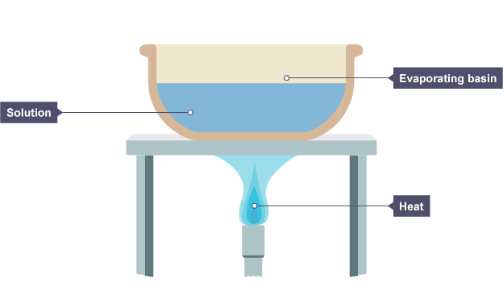

A solution is placed in an evaporating basin and heated with a Bunsen burner.

# Separating solids from liquids – filtration

If a substance does not dissolve in a solvent, we say that it is [insoluble](http://www.bbc.co.uk/education/guides/zgvc4wx/revision/1#glossary-zqfdhyc). For example, sand does not dissolve in water – it is insoluble.

[Filtration](http://www.bbc.co.uk/education/guides/zgvc4wx/revision/1#glossary-zpb7fg8) is a method for separating an insoluble solid from a liquid. When a mixture of sand and water is filtered:

* the sand stays behind in the filter paper (it becomes the [residue](http://www.bbc.co.uk/education/guides/zgvc4wx/revision/1#glossary-z9vjn39))
* the water passes through the filter paper (it becomes the [filtrate](http://www.bbc.co.uk/education/guides/zgvc4wx/revision/1#glossary-zc9vkqt))

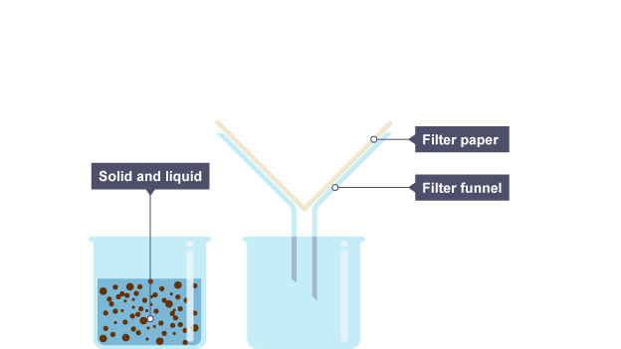

A beaker containing a mixture of insoluble solid and liquid. There is filter paper in a filter funnel above another beaker.

http://antoine.frostburg.edu/chem/senese/images/dot.gif   
  
Separating Mixtures

* components in a mixture retain their identities
* exploit properties that distinguish the components to separate mixtures

Some manufacturers add iron filings to cereal to increase its iron content! The bits of iron will stick to a magnet, but the cereal won't. So you can easily separate the mixture by stirring a bar magnet through a slurry of water and finely crushed cereal.

the more similar the properties are, the more difficult it is to separate them

Many elements occur in forms with slightly different masses. For example, uranium occurs as uranium-235, which can be used to construct atomic bombs, and uranium-238, which can't. The two are very difficult to separate because they are nearly identical otherwise. The technical difficulties in separating this mixture is one of the factors that has limited the proliferation of nuclear weapons.

* basic strategies
  + phase conversion: convert components of the mixture into other forms that are easy to isolate
  + phase transfer: add a new phase that collects some components from the mixture, but not others

|  |  |  |
| --- | --- | --- |
| **technique** | **basis for separation** | **apply this technique to:** |
| [adsorption / desorption](http://antoine.frostburg.edu/chem/senese/101/matter/separation.shtml#adsorption) | phase transfer to a solid surface | liquid or gaseous mixtures that contain at least one component that adsorbs |
| [chromatography](http://antoine.frostburg.edu/chem/senese/101/matter/chromatography.shtml) | phase transfer from a mobile mixture to a stationary phase | liquid or gaseous solutions that contain several components with differing affinities for the stationary phase |
| [condensation](http://antoine.frostburg.edu/chem/senese/101/matter/separation.shtml#condensation) | phase separation by condensing gases in the mixture to liquids | gaseous mixtures containing at least one gas with a much higher boiling point than the others |
| [dialysis](http://antoine.frostburg.edu/chem/senese/101/matter/separation.shtml#dialysis) | phase transfer through a porous membrane that allows some molecules to pass through, but not others | solutions containing small molecules mixed with very large molecules |
| [effusion](http://antoine.frostburg.edu/chem/senese/101/matter/separation.shtml#effusion) | gases with faster molecules flow through tiny pinholes faster than gases with slow molecules | gaseous mixtures containing gases with different molecular weights |
| [dissolution](http://antoine.frostburg.edu/chem/senese/101/matter/separation.shtml#dissolution) (washing, [solvent extraction](http://antoine.frostburg.edu/chem/senese/101/matter/separation.shtml#solvent%20extraction)) | soluble components can be washed away, leaving behind insoluble components (phase transfer to a washing solvent) | mixtures of solids with different solubilities |
| [electrorefining](http://antoine.frostburg.edu/chem/senese/101/matter/separation.shtml#electrorefining) | separate a metal from impurities by dissolving it and then plating it onto an electrode | solid mixtures with a metal as one component |
| [filtration](http://antoine.frostburg.edu/chem/senese/101/matter/separation.shtml#filtration) | collect solid particles on a filter | heterogeneous mixture containing a solid phase |
| floatation | dense components sink, and lighter ones float | heterogeneous mixture with phases with different densities |
| [ion exchange](http://antoine.frostburg.edu/chem/senese/101/matter/separation.shtml#ion%20exchange) | ions in the mixture bind to surfaces with oppositely charged sites (phase transfer to an ion exchange resin) | solutions containing ions |
| [precipitation](http://antoine.frostburg.edu/chem/senese/101/matter/separation.shtml#precipitation) | convert solutes to an easily separated solid form | solutions containing a solute that can be precipitated |
| [scrubbing](http://antoine.frostburg.edu/chem/senese/101/matter/separation.shtml#scrubbing) | bubble mixture through a solution that selectively absorbs a component (phase transfer from gas to solution) | gaseous mixtures containing a solute that can be selectively absorbed by a scrubbing solution |
| [stripping](http://antoine.frostburg.edu/chem/senese/101/matter/separation.shtml#stripping) | a gas bubbled through the mixture carries off the most volatile components  (phase transfer from solution to gas) | a liquid mixture containing at least one volatile component |
| [volatilization](http://antoine.frostburg.edu/chem/senese/101/matter/separation.shtml#volatilization)  ([drying](http://antoine.frostburg.edu/chem/senese/101/matter/separation.shtml#drying), [distillation](http://antoine.frostburg.edu/chem/senese/101/matter/separation.shtml#distillation), [sublimation](http://antoine.frostburg.edu/chem/senese/101/matter/separation.shtml#sublimation)) | components with widely differing volatility can be driven out of the mixture by heating (phase change from solid or liquid to gas) | a mixture containing components with differing volatility |

### Adsorption and desorption

* some solids bind gases and organic materials to their surfaces, removing them from mixtures
* adsorbed gases or liquids can recovered from the adsorbent material by washing with a solvent
* examples
  + activated charcoal adsorbs many gases and liquids
    - used as a "universal antidote" for poisoning
    - used in water purifiers (removes particulates, lead, copper, mercury, chlorine, hypochlorite, organics)
    - used to adsorb drugs from the blood of overdose victims
  + silica gel absorbs moisture from air

### Condensation

* cooling a vapor causes components with the highest boiling points to condense as liquids first
* examples
  + separating steam and air
  + separating oxygen and nitrogen in air

### Dialysis

* a semipermeable membrane allows some components in a mixture through, but not others
* how does the membrane distinguish components?
  + some membranes act as a "molecular sieve" that discriminates between large and small molecules
  + some membranes dissolve one component better than others
  + development of new membranes is an active area of research in industry and [government](http://www.inel.gov/technology_transfer/fact-htm/fact132.html)
* components flow spontaneously from the high concentration to low concentration side
  + pressure applied to the low concentration side can stop or even reverse this flow (*reverse osmosis*)
* examples
  + purification of blood in dialysis machines
  + purification of seawater by reverse osmosis
  + separation of pollutants from drinking water

### Effusion

* use porous membranes to separate light gases from heavy ones
  + average speed of gas molecules depends on the masses of their molecules
  + heavy molecules in a mixture move slower on average than light ones
  + gases made of light molecules diffuse through pores in membranes faster than heavy molecules
* differences from dialysis
  + membrane is permeable, not semipermeable: all gas molecules in the mixture can pass through it
  + size of molecules isn't usually important: pores in membrane are *much* larger than gas molecules
  + ...molecular velocity (and so, molecular mass) is the basis for separation, not size
* examples
  + separating helium from oxygen
  + separating uranium isotopes as volatile UF6

### Dissolution (washing)

* separate solids by washing away those that are soluble
* examples
  + separating sand and salt by water washing
  + separating feldspars from quartz in rocks by washing with hot concentrated phosphoric acid
  + separating organic stains from clothing by washing with organic solvents (dry cleaning)

### Electrorefining

* used to separate metals from impurities
* strategy
  + dissolve the impure metal
  + plate it on an electrode, using a strong electric current
  + pure metal deposits on the electrode, and the impurities stay in solution

### Filtration

* pass a mixture that contains solid particles through a porous filter
* if pores are smaller than particles, solid particles stay on filter and liquid/gaseous components pass through
* often used after separation by precipitation

### Ion exchange

* used to separate ions from mixtures
* pass the mixture over a surface that is covered with charged sites
* some ions stick to the charged sites
* examples
  + water deionization

### Precipitation

* precipitation is the conversion of a solute to solid form by chemical or physical change
* solids are then separated by filtration or floatation
* examples
  + separating mud and bacteria from water
    - a gooey aluminum hydroxide precipitate is formed in the water to carry particulates and bacteria to the bottom of a vat
    - clean water is drawn off the top
  + separating sulfate ions from water by adding barium ions
    - barium ion + sulfate = insoluble barium sulfate
  + water softening with washing soda

carbonate + calcium ion = insoluble calcium carbonate

### Scrubbing

* scrubbing is bubbling a gas stream through a solution that traps some components
* examples
  + CO2 can be separated from air by bubbling it through a solution of barium hydroxide
  + H2S can be removed from air by bubbling it through a zinc acetate solution

### Solvent extraction

* a component moves into a solvent shaken with the mixture
* works best with solvents that dissolve only one component   
  Solvent extraction can be used to extract vanillin from vanilla beans. Shaking the beans with an organic solvent like chloroform transfers organic compounds (including the vanillin) to the chloroform. Shaking the chloroform with a sodium hydroxide solution transfers the vanillin into the sodium hydroxide solution.

### Stripping

* a stream of gas bubbled through the mixture will carry off the most volatile components

Blowing air through a straw in a glass of soda will cause it to go flat, because the air carries off the volatile carbon dioxide.

* volatile components can be reclaimed from the gas by scrubbing

### Volatilization

* heating a mixture can cause low-boiling components to volatilize (vaporize)
* several variations
* distillation is collecting and condensing volatilized components

Alcohol can be separated from fermented corn mash by heating the mash to vaporize the alcohol. The vapor is collected and passed through coils of copper tubing, where it cools and condenses as a liquid once again. Moonshiners sometimes used old car radiators for the condensation step; the soldered joints added a toxic quantity of lead to the shine!

* drying is complete volatilization of some components in the mixture

Separation of water from clothes on a clothesline is one obvious example. The separation of salt from seawater using evaporating pools is another.

* sublimation is volatilization of a solid (without melting!)

Dry ice (solid carbon dioxide) is probably the most familiar example of a solid that sublimes. But water ice can also be converted directly into water vapor without melting, at low pressure. Snow on mountain peaks disappears without moistening the soil.

Separation by sublimation is sometimes called 'freeze drying'. Instant coffee is manufactured by freeze drying. (Boiling the coffee destroys the delicate molecules that give coffee its flavor, and so does exposure to air after a certain time, so distillation or simple drying isn't used). Fresh coffee is frozen to form a mixture of ice and coffee crystals. The pressure over the mixture is lowered so that the ice sublimates, leaving the coffee crystals behind.

Bottom of Form

**EVALUATION**

1. **Define and give one example each of i. A homogenous mixture and ii. A heterogenous mixture.**
2. **Define the following terms.i. filtrate ii. distillate iii sublimate**
3. **How would you separate a mixture of salt and sand?Explain.**
4. **How would you separate the component of black ink.**
5. **List and explain all the separation techniques .Describe their industrial application.**

**WEEK 10**

**PRACTICALS ON SEPERATION TECHNIQUES**